The 2020 assessment of the snow crab (*Chionoecetes opilio*) stock  
in the southern Gulf of St. Lawrence (Areas 12, 19, 12E and 12F)

M. Hébert, T. Surette, J.-F. Landry, Chassé, J., Boudreau, S., and A. Rondeau

Science Branch, Gulf Region  
Fisheries and Oceans Canada  
P. O. Box 5030  
Moncton, NB  
E1C 9B6

Foreword

This series documents the scientific basis for the evaluation of aquatic resources and ecosystems in Canada. As such, it addresses the issues of the day in the time frames required and the documents it contains are not intended as definitive statements on the subjects addressed but rather as progress reports on ongoing investigations.

Research documents are produced in the official language in which they are provided to the Secretariat.

Published by:

Fisheries and Oceans Canada   
Canadian Science Advisory Secretariat   
200 Kent Street  
Ottawa ON K1A 0E6

<http://www.dfo-mpo.gc.ca/csas-sccs/>   
[csas-sccs@dfo-mpo.gc.ca](mailto:csas-sccs@dfo-mpo.gc.ca)



© Her Majesty the Queen in Right of Canada, 2021  
ISSN 1919-5044

**Correct citation for this publication:**

Hébert, M., Surette, T., Landry, J.-F., Chassé, J., Boudreau, S., and Rondeau, A. 2021. The 2020 assessment of the snow crab (*Chionoecetes opilio*) stock in the southern Gulf of St. Lawrence (Areas 12, 19, 12E and 12F). DFO Can. Sci. Advis. Sec. Res. Doc. 2021/0XX. v + 52 p.

***Aussi disponible en français :***

*Hébert, M., Surette, T., Landry, J.-F., Chassé, J., Boudreau, S., et Rondeau, A. 2021. Évaluation du stock de crabe des neiges (Chionoecetes opilio) dans le sud du golfe du Saint-Laurent (zones 12, 19, 12E et 12F) en 2020. Secr. can. de consult. sci. du MPO. Doc. de rech. 2021/0XX. v + 54 p.*

TABLE OF CONTENTS

Abstract iv

1.0. INTRODUCTION 1

2.0. SYNOPSIS OF SNOW CRAB BIOLOGY 1

3.0. METHODS 2

3.1. OBSERVER AT-SEA MONITORING 2

3.2. LOGBOOKS AND LANDING MONITORING 2

3.3. TRAWL SURVEY SAMPLING FOR BIOMASS ESTIMATION 2

3.3.1. Trawl survey in 2020 3

3.3.2. Biological sampling 4

3.3.3. Estimation of snow crab abundance 4

3.4. EXPLOITATION RATES 5

3.5. Risk analysis and catch options 5

4.0. RESULTS 5

**4.1. FISHERY PERFORMANCE** 5

**4.1.1. Area 12** 5

**4.1.2. Area 19** 6

**4.1.3. Area 12E** 6

**4.1.4. Area 12F** 7

4.2. BIOMASS ESTIMATES FROM THE TRAWL SURVEY 7

4.2.1. trawling characteristics during the 2020 survey 7

4.2.2. Variogram 8

4.2.3. SOUTHERN GULF Biomass estimates IN 2020 9

4.2.4. Estimation of the portion of total biomass in each management fishing zone and buffer zoneS 10

4.3. EXPLOITATION RATE 10

4.4. Reproductive potential AND Recruitment 10

5.0. RISK ANALYSIS OF CATCH OPTIONS FOR 2021 11

6.0. UNCERTAINTIES 12

7.0. ENVIRONMENTAL CONSIDERATIONS 13

8.0. ACKNOWLEDGMENTS 14

8.0. REFERENCES CITED 14

TABLES 18

FIGURES 28

## 

## Abstract

The 2020 assessment of the southern Gulf of St. Lawrence (sGSL) snow crab, *Chionoecetes opilio*, stock (Areas 12, 19, 12E and 12F) is presented. Snow crab in the sGSL is considered as a single stock unit for assessment purposes. The 2020 assessment was conducted as per the recommendations of the Snow Crab Assessment Methods Framework Science Review held in November 2011. Landings in the sGSL in 2020 were of 28,156 t. The catch per unit of effort (CPUE) decreased in all zones during the 2020 fishery. Concerns of biomass overestimation were raised during the 2019 assessment and persisted in 2020. Indicators of survey biases were presented with supporting data. The exploitation rate of the 2020 fishery was estimated at 35.6 % based on the 2019 survey commercial biomass estimate. However, overestimation of the commercial biomass would imply that the exploitation rate during the 2020 fishing season was higher than estimated. The 2020 commercial biomass was estimated at 77,748 t and composed of 75 % recruitment and 25 % of residual biomass. Overestimation biases ranged from 30 to 40 % among mature females and sub-legal males. Overestimation bias estimates among commercial crab were estimated at 14 %, though this value was deemed less reliable because of complex fishery-related dynamics. Recurrent overestimations of the commercial biomass would result in exploitation rates exceeding the agreed upon level in the Precautionary Approach harvest decision rules. The risks of biomass indicators falling under the limit and upper stock reference points assuming different levels of overestimation biases were presented. However, no consensus on the level of overestimation bias was reached. Despite overestimation in the abundance indices, the stock continues to show signs of sustained recruitment and productivity. Overall, the stock is expected to remain in the healthy zone of the Precautionary Approach. A plan will be developed to address bias and catchability issues for the upcoming surveys and consistency in the indicators used in the stock assessment. There is continued evidence of warming conditions in the sGSL and the extent to which it could impact snow crab population dynamics and distribution is not well understood.

Résumé

L’évaluation du stock de crabe des neiges, *Chionoecetes opilio*, du sud du golfe du Saint-Laurent (sgSL) de 2020 est présentée (zones 12, 19 12E et 12F). Le crabe des neiges dans le sgSL est considéré comme une seule unité de stock aux fins d’évaluation. L’évaluation de 2020 a été effectuée selon les recommandations suite à l’examen cadre des méthodes d'évaluation du stock de crabe des neiges dans le sgSL tenu en novembre 2011. Les débarquements dans le sgSL en 2020 ont atteint 28 156 t. Les captures par unité d’effort (CPUE) ont diminué dans toutes les zones lors de la pêche de 2020. Des inquiétudes concernant la surestimation de la biomasse ont été soulevées lors de l’évaluation de 2019 et ont persisté en 2020. Les biais des indicateurs du relevé ont été présentés avec des données. Le taux d’exploitation de la pêche de 2020 a été estimé à 35,6 % d’après l’estimation de la biomasse commerciale dans le relevé de 2019. Cependant, une surestimation signifierait que le taux d’exploitation est plus élevé que celui estimé. La biomasse commerciale de 2020 a été estimée à 77 748 t et était composée de 75 % de recrutement et de 25 % de biomasse résiduelle. Les biais de surestimation allaient de 30 à 40 % chez les femelles adultes et les mâles de taille inférieure à la taille légale. Le biais de surestimation chez les crabes de taille réglementaire a été estimé à 14 %, bien que cette valeur ait été jugée moins fiable en raison de la dynamique complexe de la pêche. Des surestimations récurrentes de la biomasse commerciale entraîneraient des taux d’exploitation dépassant le niveau convenu dans les règles de décision sur les prises selon l’approche de précaution. Les risques que les indicateurs de la biomasse tombent sous les points de référence limite et supérieur du stock en supposant différents niveaux de biais de surestimation ont été présentés. Cependant, aucun consensus sur un niveau de biais de surestimation n’a été atteint. Malgré la surestimation des indices de l’abondance, le stock affiche encore des signes de recrutement et de productivité soutenus. Dans l’ensemble, le stock devrait demeurer dans la zone saine du Cadre de l’approche de précaution. Un plan sera élaboré afin de traiter les questions de biais et de capturabilité pour les prochains relevés et la cohérence des indicateurs utilisés dans l’évaluation du stock. Il existe des preuves continues des conditions de réchauffement dans le sud du golfe du Saint-Laurent et on ne comprend pas encore bien dans quelle mesure elles pourraient se répercuter sur la dynamique et la répartition des populations de crabe des neiges.

## 1.0. INTRODUCTION

The southern Gulf of St. Lawrence (sGSL) snow crab (*Chionoecetes opilio*) fishery has evolved to be one of the commercially dominant fisheries in the region since its beginnings in the mid-1960s. Snow crabs in the sGSL are considered to be made up of a single biological population, though limited migratory exchanges between the Quebec to the north and the eastern Cape Breton snow crab populations to the southeast are known (Hébert et al. 2008), and significant larval inputs to come from the Quebec population. Currently, the sGSL is divided into four management Areas, named 12, 19, 12E and 12F (Fig. 1), with Area 12 being the largest in area, number of participants, and landings. There is no biological basis for the chosen boundaries of these management areas (Chiasson and Hébert 1990; Hébert et al. 2008; DFO 2009).

## 1.1. MANAGEMENT OF THE FISHERY

Management of the snow crab fishery is based on quotas (by management area and distributed among license holders) and effort controls (number of licenses, trap allocations, trap dimensions, and seasons). The fishing season in Areas 12, 12E and 12F generally starts as soon as the sGSL is clear of ice in late April to early May and lasts either until the closure of the fishing season in mid-July or when the quota is caught. In Area 19, the fishing season starts in July and ends in mid-September or when the quota is caught. The landing of female snow crab is prohibited and only hard-shelled males ≥ 95 mm carapace width (CW) are commercially exploited. The number of traps per license varies by harvester group and fishing area.

The fishery is also subject to two types of local area-closures during the fishing season. The first type arises from the application of a soft- and white-crab protocol, which aims to limit the quantity of newly-molted crab in at-sea catches, as they represent future recruits to the fishery and are vulnerable to discard mortality. The second type of area closures are those that aim to minimize entanglement risks between Northern Atlantic Right Whales and fishing gear, which has been an ongoing concern since 2017, resulting in significant displacements in fleet fishing effort.

## 1.2. SURVEY CATCHABILITY ISSUES in 2019 & 2020

Stock status for sGSL snow crab is determined using fishery-independent stock indices from a dedicated bottom trawl survey that is conducted each year after the end of the fishery. In order to be reliable, survey indices must scale predictably with the size of the biological population as it varies through time. However, stock indices from the 2019 and 2020 were cast into doubt owing to an apparent increase in survey catchability, coinciding with a change in survey vessel. Specifically, survey catches increased among sub-legal male crab (from 34 to 95 mm CW) and mature female crab increased by 30-40% year-over-year. These large increases cannot be explained by natural processes such as recruitment, migration or mortality, strongly pointing towards increasing survey catchability as a likely cause.

This issue has naturally led to questions regarding the long-held working assumption of perfect and constant catchability among commercial crab over the time series, i.e. that the 2019 and 2020 commercial abundance and biomass estimates may not be accurate reflections of true commercial stock size. Since reference points for sGSL snow crab are based on estimates of commercial crab biomass from the survey, this uncertainty has undermined our ability to assess sGSL snow crab stock status and make sound quota risk assessments for the 2021 fishing season. Consequently, Science recommendations for the 2021 season were more precautionary under this added uncertainty.

As such, the present report contains a regular summary of the 2020 snow crab fishery, but the assessment of stock status was modified to consider the presence of bias in commercial biomass estimates for the upcoming 2021 sGSL snow crab fishery.

## 2.0. Development of the fishery

Until 1994, the snow crab fishery in Area 12 (Fig. 1) was exploited by 130 mid-shore crab harvesters from New Brunswick, Québec and Nova Scotia. In 1997, the Prince Edward Island (PEI) coastal fishery (formerly called Areas 25/26) was integrated into Area 12. In 2003, a portion of the coastal fishery off Cape Breton (formerly called Area 18) was also integrated into Area 12, and a northern part of Area 18 was set as a buffer zone (non-snow crab fishing zone, label C in Fig. 1). For the purpose of this assessment, Area 12 refers to the new management unit (Fig. 1). In 1978, Area 19 (Fig. 1) was established for the exclusive use of Cape Breton inshore crab harvesters with vessels less than 13.7 m (45 ft) in length. Areas 12E and 12F were introduced in 1995 as exploratory fishery areas. A two nautical mile buffer zone was created between Area 12F and the adjacent Area 19 in 1996 (label B in Fig. 1). In 2002, the status of Areas 12E and 12F was changed from exploratory to commercial.

## 2.1. SYNOPSIS OF SNOW CRAB BIOLOGY

In the sGSL, molting of snow crab occurs from December to April, prior to the fishery (Watson 1972; Conan et al. 1988; Sainte-Marie et al. 1995; Benhalima et al. 1998; Hébert et al. 2002). Crab normally molt annually until they reach the adult stage via a final or “terminal” molt (Conan and Comeau 1986). Adult males range in size from 40 up to 150 mm CW and adult females from 30 to 95 mm CW (Conan and Comeau 1986). After molting, longevity of adult males (i.e. crab that have terminally molted) is estimated to be between 5 (Sainte-Marie et al. 1995) and 8 years (Fonseca et al. 2008).

Females undergo a terminal molt between December and April and mate immediately after molting, while their carapace is still soft, and then extrude their first clutch of fertilized eggs. We refer to these females as primiparous (Watson 1969; Moriyasu and Conan 1988). Females that are incubating their second or third brood are referred to as multiparous. Multiparous females mate from late-May to early-June, after their previous egg clutch has been hatched and released (Conan and Comeau 1986; Moriyasu and Conan 1988; Sainte-Marie and Hazel 1992; Moriyasu and Comeau 1996; Sainte-Marie et al. 1999). In the sGSL, a majority of mature females incubate their eggs for two years (Mallet et al. 1993; Moriyasu and Lanteigne 1998), while a small proportion may follow a one-year cycle. However, Khun and Choi (2011) reported that over 80% of mature females were estimated to follow a one-year reproductive cycle on the Scotian Shelf.

After molting, crabs shells are soft and their bodies are engorged with water. Adult males require about 8-10 months for their carapaces to harden (Hébert et al. 2002) and one year to attain maximal meat yield (Dufour et al. 1997). Soft-shelled adult males are physically vulnerable and only mate the following year (Conan et al. 1988; Moriyasu et al. 1988). A categorical scale from 1 (soft) to 5 (old-shell), referred to as carapace condition, is used to distinguish between newly molted crab, and crab that have molted in previous years (Hébert et al. 1997). Legal-sized soft-shelled adult males represent the annual recruitment to the fishery, as they become commercially marketable in the following year’s fishing season (Conan and Comeau 1986; Sainte-Marie et al. 1995; Comeau et al. 1998; Hébert et al. 2002). Following Sainte-Marie et al. (1995), we use the terms “adolescent” and “adult” to refer to crab which are morphometrically immature and mature, respectively (Conan and Comeau 1986).

## 3.0. METHODS

## 3.1. OBSERVER AT-SEA MONITORING

Under Covid-19 restrictions, very few at-sea observers were deployed aboard snow crab vessels in areas 12, 12E and 12F during the 2020 fishing season. Consequently, soft-shelled crab monitoring and area closure protocols in for the 2020 season were not applied. However, the protocol for white-shelled crab was applied in Area 19 with the easing of Covid-19 restrictions in July 2020. Given the limited absence or sparseness of available data, fishery-performance indicators based on at-sea observer data were not estimated in this assessment. These included the fishery catch composition, the percentage of-soft-shelled and white crab in catches, the CPUE and the mean size of commercial-sized adult males.

## 3.2. LOGBOOKS AND LANDING MONITORING

Raw data on catches and fishing effort were obtained from mandatory logbooks and the quota monitoring report, which is based on dockside monitoring of landings. The data were compiled by the Statistics Divisions of the Quebec and Gulf Regions of The Department of Fisheries and Oceans (DFO), and verified by Science Gulf Region. Information on revised quotas, allocation shares, trap allocations and opening dates for the fishery per area were obtained from DFO Fishery Aquaculture and Management sector.

The geographic distribution of fishing effort is presented as the total number of trap hauls within each 10’x10’ latitude-longitude grid, with fishing positions obtained from logbooks.

Catch-per-unit-of-effort (CPUE) in kilograms per trap haul (kg/th) per year (*i*) per fishing area (*j*) was calculated as the ratio of total landed catches (*yij*) and the corresponding number of trap hauls (*hij*) as reported in the logbooks: CPUEij = *yij* / *hij*. As not all trap hauls were reported in the logbooks, the total number of trap hauls had to be estimated from the total landings from the quota monitoring report (*Lij*) divided by the unadjusted mean CPUE: hij = Lij / CPUEij.

## 3.3. TRAWL SURVEY

## 3.3.1 SYNOPSIS of TRAWL SURVEY DESIGN CHANGES

The sGSL snow crab trawl survey has undergone changes in the sampling design, survey area and sampling protocols since its inception in 1988. Originally, the survey area was much smaller and sub-divided using a lattice of 10’x10’ latitude-longitude grids. A few sampling locations were then randomly selected and used as fixed stations in subsequent survey years, though stations were sometimes discarded or displaced over subsequent years.

Two major methodological reviews occurred in 2005 (DFO 2006; Moriyasu et al. 2008) and 2011 (DFO 2012a; Wade et al. 2014), which resulted in major changes in survey design in 2006 and 2012, respectively. In 2006, a large portion of survey stations were redistributed with the 10’x10’ lattice-grid design so as to obtain a more spatially homogeneous distribution of sampling stations.

In 2012, the 10’x10’ lattice-grid layout was discarded in favor of square grids defined over a UTM projection. This change was also accompanied by an expansion of the survey area boundaries to the 20 and 200 fathom isobaths, which encompasses the vast majority of sGSL snow crab distribution and habitat (i.e. bottom temperatures less than 5°C). These design changes also led to an entirely new set of sampling station locations being chosen for both 2012 (325 stations) and 2013 (355 stations). Station locations have been held more or less as fixed since 2013, though individual station displacements have accrued over time to mitigate trawl damage.

## 3.3.2. Trawl survey in 2020

In 2020, the number of target sampling stations remained at 355. The 350 successful sampling stations from the 2019 trawl survey were used as fixed stations in 2020 and a new set of five sampling stations (the three sampling stations that were abandoned and two sampling stations that were conducted outside their assigned square grid areas in 2019) were randomly generated (Fig. 2).

The Avalon Voyager II, a 65-foot stern-trawling (850 HP) fiberglass boat, was used to conduct the 2020 trawl survey between July 13th and September 10th (Fig. 2). A total of 353 stations were successfully trawled in 2020; two sampling grids were abandoned due to sampling difficulty. For a description of the trawl used, see Moriyasu et al. (2008).

All stations were fished between morning and evening civil twilight hours. A 3:1 warp-to-depth ratio was applied at all stations, to a maximum warp length of 550-575 fathoms. The start time of each tow was estimated using data from a Star Oddi tilt-angle probe attached to the trawl footrope. The target duration of each tow was five minutes at a target speed of two knots. The area swept by the trawl was calculated using the width of the trawl opening, as measured using a pair of eSonar sensors affixed to the trawl wings, and the speed of the survey vessel according to GPS observations.

Tows were rejected if the net was significantly damaged. Replacement tows were conducted either near the original start point or at randomly selected alternate sampling stations within the sampled grid (Fig. 2). If the tow satisfied trawl survey protocols but the data signal quality from the eSonar sensors was deemed to be inadequate to calculate the swept area, the swept area of the tow was set to the average of the values of the 10 nearest stations.

## 3.3.3. Biological sampling

Survey catches were sorted by species or of taxonomic group directly on the vessel deck. All snow crab were measured for carapace width (CW), chela height (CH) for males, carapace condition, egg clutch characteristics for females, namely color (orange, dark orange, brown or black) and quantity (rough percentage), as well as gonad color (white, beige or orange) among adolescent females.

Other species or taxonomic groups in the catch were weighed and counted. For a subset of 100 randomly selected survey sampled stations, up to 100 fish per species were measured for length using an electronic measuring board.

## 3.3.4. Snow CRAb biological categories

The following definitions were used to specify snow crab biological categories contained in this assessment.

Commercial crab are defined as adult male crab ≥ 95 mm CW. Commercial crab are divided into two component groups: new recruits to the fishery (also called R-1 crab), identified as crab having soft-shelled carapace conditions 1 & 2; and remaining biomass, which represents the portion of the exploitable biomass that is left over after the fishery, identified as crab having hard-shelled carapace conditions 3, 4 and 5. By inverting a growth model (Hébert et al. 2002), commercial recruitment can be traced back to adolescent male categories that will by recruit in two (called R-2), three (called R-3), and four (called R-4), years’ time, corresponding to adolescent males with a size range of 56-68 mm CW, 69-83 mm CW and larger than 83 mm CW, respectively. Instar VIII adolescent male crab (34-44 mm CW) is used as a long-term population recruitment index.

Female snow crab are classified by maturity group, namely pubescent females, which are immature females with developing gonads, primiparous females, which are newly matured females carrying their first clutch of eggs, and multiparous females, which are mature females carrying their second or third clutch of eggs.

These biological categories can be summarized as indices of commercial biomass (recruitment and residual), fishery recruitment indices (R-2, R-3, and R-4), population recruitment indices (instar VIII) and spawning stock indices (pubescent, primiparous and multiparous females).

## 3.3.5. Estimation of abundance and Biomass

The survey area polygon has a total surface area of 57,842.8 km2 (Fig. 3) and the four corresponding management areas within this polygon have surface areas of 48,074 km2 for Area 12, 3,813 km2 for Area 19, 2,436.9 km2 for Area 12E and 2,426.8 km2 for Area 12F (Fig. 3). Contained within the survey area is an additional zone A, with an area of 667.9 km2, that lies above Areas 12E and 12F (Fig. 3) and does not assigned to any snow crab management area. Buffer zones B and C (Fig. 3) cover an area of 134.2 and 289.5 km2, respectively.

Kriging with external drift (KED) was used to estimate all abundance and biomass indices (DFO 2012a). This geostatistical method proceeds in two steps; first by modelling the spatial covariance between survey catch observations, then making spatial predictions of local density that also incorporates depth as a secondary variable. Spatial covariance was calculated using a fitted variogram function, which models the degree of dissimilarity between pairs of observations as a function of their distance of separation. A three-year averaged variogram was used, deemed to be more stable than only using the survey year’s data (Wade et al. 2014). Note that, for the purposes of this assessment, abundance and biomass estimates within management zones do not include buffer zones. All survey catch observations were standardized using estimates of trawl swept area prior to analysis. For biomass estimates, crab counts at each tow were first converted to weights using the size-weight relationship *w* = (2.665 x 10-4) CW 3.098, where *w* is the weight in grams and CW is the carapace width in mm (Hébert et al. 1992).

**Given the uncertainty regarding survey catchability for 2019 and 2020, abundance and biomass indices from these years, which include commercial biomass estimates, are understood as overestimated relative to estimates from previous surveys, and were flagged as unadjusted values throughout the remaining document. Treatment of this bias and its associated uncertainty was shifted to the risk assessment, which considered a range of estimation biases to compensate for the observed increase in survey catchability. Portions of past assessments that were deemed too severely affected by the survey catchability increase were removed.**

## 3.4. EXPLOITATION RATES

For the purpose of this assessment, exploitations rates *(ER)* for the sGSL were calculated as the ratio of the fishery landings *Lt* for fishing year *t* and the commercial biomass *Bt-1* from the previous year.

*ER = Lt / Bt-1*

Note that this definition of exploitation rate does not take into account any natural mortality that may have occurred before or during the fishery.

## 3.5. Risk analysis and catch options

The risk analysis calculated the probabilities of two events: that the remaining biomass from the 2021 survey falls below the Upper Stock Reference of 10,000 t, or that the total commercial biomass from the 2021 survey falls below the limit reference point of 41,000 t. These probabilities were calculated using projected recruitment biomass to the fishery (R-1) in 2021, application of the average mortality rate in the past 5-years, and application of the proposed TAC level.

The projected R-1 biomass in 2021 was estimated using a Bayesian model described in Surette and Wade (2006) and Wade et al. (2014), based on survey abundances of pre-recruits R-4, R-3 and R-2. The model incorporated estimation errors in the abundances.

TACs were set according to the prescribed Harvest Control Rule for snow crab (ref)

The impact of varying levels of bias on these risk probabilities was considered, along with the bias assicated with the R-1 projection.

**Clearly state the APPROACH HERE!**

## 4.0. RESULTS

**4.1. FISHERY PERFORMANCE**

Since 1969, four periods of high landings exceeding 20,000 t have been observed in the sGSL: 1981-1986, 1994-1995, 2002-2009 and more recently from 2012 to 2020 (Fig. 4). Landings in the sGSL were 28,156 t in 2020 (revised quota of 31,152 t) while they were 31,707 t in 2019 (revised quota of 32,215 t) (Table 1; Fig. 4). By reason of quota adjustments, reconciliations, and re-distribution of the scientific quota among areas, the revised quota does not exactly match the TAC given in the notice to harvesters, which was set at 31,341 t in 2020.

**4.1.1. Area 12**

The 2020 fishing season in Area 12 opened on April 24 and the last landings were recorded on July 1 with reported landings of 24,554 t from revised quota of 27,435 t, which represents 89.5% of the quota. The allowable quota from the notice to harvesters was initially 27,204 t. Harvesters participating in the fishery were from New Brunswick, Quebec, Nova Scotia and Prince Edward Island. The number of participating fishing vessels was 309 in 2020 and 321 in 2019.

Fishing effort in Area 12 varied from 243,339 to 544,454 trap hauls (th) between 1987 and 2009, but decreased considerably to 161,148 th in 2010, the lowest value of the time series since 1987 (Table 1). The fishing effort then increased to 339,912 th in 2015, decreased slightly to 304,624 th in 2016, then saw a large increase to 553,125 th in 2017. In 2020, the fishing effort was slightly above that of 2017 at a record 556,780 th, representing an increase from 2019 at 496,468 th (Table 1). During the 2020 fishing season, fishing effort in Area 12 was concentrated mostly in Chaleur Bay, the Shediac valley, the Bradelle Bank, the Magdalen Channel and the Cape Breton Corridor (Fig. 5). Landings were similarly distributed (Fig. 6).

The logbook-derived CPUE for Area 12 was 44.1 kg/th in 2020, a decrease from 55.5 kg/th compared to 2019 (Table 1). High CPUEs were observed in Bradelle bank, Orphan bank, the north and central parts of the Magdalen Channel and in the Cape Breton Corridor (Fig. 7).

Trap immersion times are shown in Table 2a. Since 1997, times in Area 12 have varied from 55 hours (2003) to 88 hours (2017). The mean trap immersion time in 2020 was 75 hours while it was 73 hours in 2019 (Table 2).

**4.1.2. Area 12E**

In Area 12E, the 2020 fishery opened on April 24 and the last day of landings were recorded on June 30, with reported landings of 234 t from a revised quota of 238 t. The quota from the notice to harvesters was 239 t. Four vessels were active for the 2020 fishing season.

Harvesters concentrated their fishing effort in the southeastern part of the area adjacent to Areas 12 and 12F (Fig. 5). The fishing effort decreased from 9,232 th in 2008 to 1,825 th in 2010 but increased to 5,623 th in 2012 (Table 1). The fishing effort decreased to 2,796 th by 2016 (Table 1). Since 2016, the fishing effort increased to reach 5,579 th in 2018 (Table1). In 2019, the fishing effort decreased to 3,415 th but increased to 5,098 th in 2020 (Table 1).

Mean CPUE from Area 12E from logbooks was 45.9 kg/th in 2019, a decrease compared to 65.7 kg/th in 2019 (Table 1).

Since 1997, the mean trap immersion time has varied between 30 hours in 1998 and 72 hours in 2009. The mean trap immersion time decreased to 54 hours in 2020 compared to 66 hours in 2019 (Table 2).

**4.1.3. Area 12F**

In Area 12F, the 2020 fishery opened on April 24 and the last landings were recorded on July 1 with reported landings of 1,084 t from a quota of 1,192 t. The allowable quota from the notice to harvesters was 1,192 t. There were 24 active vessels in 2020.

The fishing effort was distributed all over Area 12F (Fig. 5). The fishing effort decreased from 16,890 th in 2012 to 11,086 th in 2013 but increased to 23,163 th in 2014 (Table 1). The fishing effort decreased to 8,667 th by 2016 but increased to 23,982 th in 2020 (Table 1).

Mean CPUE from Area 12F from logbooks decreased in 2020 (45.2 kg/th) compared to 2019 (64.5 kg/th, Table 1).

Since 1997, the mean trap immersion time has varied between 49 hours (1997) and 118 hours (2011). The mean trap immersion time in 2020 (88 hours) increased compared to 2019 (83 hours, Table 2).

**4.1.4. Area 19**

The 2020 fishing season in Area 19 opened on July 2 and the last landings were recorded on August 13. Reported landings were 2,284 t from a revised quota of 2,287 t. The allowable quota from the notice to harvesters was 2,255 t. The number of boats fishing in Area 19 in 2020 was 103 (all from Cape Breton) compared to 109 in 2019.

The fishing effort during 2020 in Area 19 was concentrated in the southern part of the zone where the highest landings were taken while high CPUEs were observed all over the zone (Figs. 5, 6 and 7). The fishing effort has varied from 16,733 th to 55,977 th between 1987 and 2009, but decreased considerably to 11,138 th in 2010, the lowest value of the time series (Table 1). The fishing effort increased to 25,407 th in 2014 and decreased to 11,937 th by 2016 (Table 1). In 2019, the fishing effort increased to 24,518 th but decreased to 22,458 th in 2020 (Table 1).

Logbook CPUEs remained high in 2020 (101.7 kg/th), a decrease compared to 2019 (112.7 kg/th (Table 1). The highest mean CPUE was observed in 2012 at 178.1 kg/th (Table 1).

Since 1997, mean trap immersion times in Area 19 have varied from a low of 28 hours in 2004 to 38 hours in 2003 and 2017 (Table 2). In 2020, the value was 33 hours, up from 31 hours in 2019 (Table 2).

## 4.2. Catchability issues IN 2019 and 2020

The change in survey vessel in 2019 was accompanied by significant catch increases across a wide range of crab sizes. Figure 9 shows a year-over-year comparison of standardized size-frequency distributions for 2018 and 2019, which shows that the increases are on the scale of 30-40% among male crab from 34 mm to 95 mm CW and mature female crab.

These increases cannot be explained by any combination of natural processes such as recruitment, migration or mortality. Specifically, strong population recruitment pulses are observed in only in a limited range of small sizes, migration on this scale would effectively require emptying of neighboring populations in Quebec and eastern Cape Breton, and exceptionally low mortality would only have maintained 2018 levels in 2019, not have increased them.

The led us to conclude that these catch increases were due to an increase in survey catchability in 2019, relative to the 2018 survey, at least among the above mentioned crab categories. Consequently, population estimates for these categories or any subset thereof would be overestimated by at least 30-40%, relative to 2018. Meaningful comparisons of abundance and biomass indices between different years rest on the assumption of constant survey catchability over time. Under changing catchability, indices may no longer accurately reflect changes in stock size.

## 4.2.1. PASSIVE PHASE TRAWLING

When the catchability issues first appeared in 2019, data stemming from probes attached to the trawl were analyzed for years 2017, 2018 and 2019 to determine if there were any differences in trawl or fishing behavior that could point to a mechanistic cause.

This analysis showed that a latent passive trawling phase existed between the trawl stop signal, at which point the winch is activated, and the time the trawl lifted off the bottom. While swept area during active trawling is used to standardize catches, that of the passive trawling phase is not, leading to potential biases in the perceived local crab densities that form the basis of abundance and biomass estimates used in the assessment. Moreover, it was shown that swept area during the passive trawling phase had increased from 1,014 m2 and 938 m2 in 2017 and 2018, respectively, to 1,270 m2 in 2019 (Hébert et al. 2021). It was shown that this increase was due to slower operation of the winch during hauling of the trawl. This being said, when the passive swept area estimates were included in the catch standardization, the expected catch increase of 2019, relative to 2018 was only 12.9% DFO 2020), which fell short of the 30-40% that was observed among sub-legal crab.

For the 2020 survey, winch speed was increased to levels comparable to 2017 and 2018 and the vessel decelerated more strongly during winching of the trawl, so as to minimize trawl dragging of the trawl. Figure 8 shows survey vessel movement for 2017 to 2020 during the active and passive trawling phases. As the passive swept area estimates showed, forward movement of the survey vessel was longer in 2019, relative to 2017 and 2018. Under the protocol change in 2020, vessel movement during the passive phase was much reduced; with the vessel often turning sideways after the stop was signaled.

As expected from the increased winch speed, the time required to haul the trawl doors to the water’s surface decreased from an average of 312 seconds (s) in 2019 to 218 s in 2020, which was even lower than the average of 263 s observed in 2017. However, the average time spent by the trawl on the bottom during winching, i.e. the duration of the passive trawling phase, increased slightly from 116 s in 2019 to 130 s in 2020, both of which are longer than the values of 82 s in 2017 and 75 s observed in 2018.

One way to explain this counterintuitive result is to consider how the tension in the trawl cables changed in response to the protocol changes in 2020. Since the vessel moved much less during winching than in 2019, cable tension likely decreased, requiring the trawl to be much closer to the survey vessel before lifting off the bottom, owing to an overall reduction in cable tension due to the vessel speed reduction, which counteracted the increase in winch speed. Also, because the vessel changed heading after the stop signal in 2020, passive phase swept areas could not be calculated using the method used in 2017, 2018 and 2019. Thus, though the duration of the phase is longer in 2020, it is unknown whether this translated in further dragging of the trawl, relative to 2019.

We note that trawl catchability during the passive trawling phase is likely much more dynamic than during active trawling, due to large changes in cable tension and hoisting angle during hauling. While the center of the footrope, where the tilt-probe is attached, remains on the bottom, it is likely that the trawl doors and trawl wings are lifting off the bottom, during the passive trawling phase. In other words, catchability of the trawl during the passive phase is likely sub-optimal and may only be a fraction of that during active trawling.

## 4.2.2. IMPLIcations for COMMERCIAL CRAB

In contrast to sub-legal crab, commercial sized-crab abundance and biomass remained at stable levels over the same period from 2018, 2019 and 2020.

* Does this mean that legal-sized crabs were not affected by the catchability increases among their sub-legal counterparts?
* We may not draw this inference because, in contrast to sub-legal crab, the dynamics among legal-sized are more complex, being under the strong direct (landings) and indirect (discard mortality) influence of the fishery.
* Some mechanistic explanations such as an prolonged passive trawling phase would be expected to inflate legal-sized catches to the same degree as those of sub-legal catches.
* Though some mechanistic explanations may lead to size-dependent catcahbility differences between sub-legal and legal-sized crab, it is difficult to explain why the legal-sized component remained unchanged despite the significant unchanged in the face of such a signif

This being said, different hypotheses were proposed to explain this apparent stability of the commercial index of the crab stock in 2019 and 2020 despite the survey catchability increases among sub-legal male and female crab.

Likely hypotheses are; 1) a strong increase in commercial-sized male crab mortality in 2019 and 2020 that counterbalanced a survey catch increase among commercial crab that would otherwise have been observed and, 2) that survey catchability increases are size-dependent and strongly focused on sub-legal-sized crab.

Other proposed hypotheses were large-scale crab migration, or increases in catchability located in areas of high female and sub-legal male abundance. However, these additional hypotheses cannot account for the degree of the increases nor their restricted association to sub-legal sizes.

* Other mechanistic explanations, such as variable footrope contact, may lead to catchability that varies with size.
* Given these factors, quantifying the increase in catchability on commercial-sized males component is difficult to resolve.

In addition, fishery indicators in 2020 suggest an overestimation of the commercial biomass from the 2019 trawl survey. There was a decrease in the mean CPUE in all areas. A rapid decline in the weekly CPUE was observed throughout the fishing season. The quota was not reached in Area 12 (89%) and showed the highest fishing effort in the history of that fishery.

* No numerical estimates of bias svp

As a result of the 2020 fishery performance and the repeated high catches of mature female and sub-legal male snow crab in 2020, methods were proposed to estimate the potential bias on the commercial-sized male survey biomass using the 2020 fishery landings data and/or the residual biomass from the 2020 post-fishery survey. The first method compared the sum of the 2020 landings plus the 2020 residual biomass with the commercial biomass estimate from the 2019 survey with a 70 % survival rate applied (5-years moving average on commercial-sized adult males). The sum of the residual biomass plus the landings in 2020 was 14.4 % lower than the commercial biomass estimate from the 2019 survey (Table 3). This difference between the predicted and observed biomass values suggests an overestimation bias of 14.4 % in the commercial biomass for the 2020 fishery. Moreover, the overestimation of the survey indices would also apply to the residual biomass estimate, resulting in the difference from the method described above being possibly higher than 14.4 %.

A Leslie analysis was explored as a second method, estimating the initial, or pre-fishery, biomass based on the depletion of the weekly CPUE during the 2020 fishery (Fig. 10). The use of CPUE as core data raised concerns as fishery catches are known to be influenced by many factors and may not reflect true stock abundance signals. While the results of the Leslie analysis supported an overestimation bias of >14.4 % on the commercial biomass estimate, the method was deemed unreliable.

In summary, data are suggesting that mature female and sub-legal male abundance indices for 2019 and 2020 are over-estimated by 30-40 %, while commercial-sized crab could be over-estimated by at least 14.4 %. These biases will be considered in the following assessment and risk analysis, though corrections will not be directly applied, unless otherwise stated.

## 4.3. ABUNDANCE and BIOMASS ESTIMATION

Keeping in mind the survey catchability issues highlighted above, we present here abundance and biomass indices from the 2020 survey, in their unadjusted form. It is to be understood that all 2019 and 2020 abundance and biomass values are likely over-estimated with respect to the 2017 and 2018 surveys. The impact of these over-estimation biases will be treated in the risk analysis section.

## 4.3.1. UNADJUSTED SOUTHERN GULF Biomass estimates IN 2020

Commercial biomass for the 2020 survey was estimated using the prescribed kriging method. The variogram used in the kriging was a three-year average model had a nugget value of 2.895 x 106, a sill at 3.751 x 106 and a range of 68.3 km (Fig.11).

The unadjusted commercial biomass for the sGSL is estimated at 77,748 t (95% confidence interval (C.I.) range of 67,706 to 88,852 t), which is similar to the 2019 estimate of 79,066 t (69,072 to 90,091 t) (Table 4). The recruitment to the fishery at the time of the 2020 survey was estimated at 58,438 t (49,759 to 68,189 t). The recruitment to the fishery represents 75.2% of the commercial biomass (Table 4). The 2020 residual biomass (adult commercial-sized males with carapace conditions 3, 4 and 5) was estimated at 19,107 t (16,235 to 22,339 t), a decrease of 5.8% compared to the 2019 estimate of 20,291 t (16,940 to 24,109 t) (Table 4).

In 2020, local concentrations of commercial crab were mainly observed in Bradelle Bank, Shediac valley, Chaleur Bay, Area 12F, in the central and southern parts of the Magdalen channel and in the southeastern part of the sGSL, which included Area 19 and the Cape Breton Corridor (Fig. 12).

Commercial crabs were comprised of 73.4% fishery recruitment (carapace conditions 1 and 2) and 26.6% residual biomass (carapace conditions 3, 4 and 5) (Table 5). The residual biomass was composed of 79.3% carapace condition 3, 19.2% of crabs with carapace condition 4 and 1.5% of crabs with carapace condition 5 (Table 5). The large proportion of carapace condition 3 in the residual biomass shows that the post-fishery population is young and does not show signs of an ageing population.

A comparison between fishery recruitment predicted by the Bayesian model for the fishery of 2020 (74,280 t; 95% C.I. 49,300 to 107,400 t) and the recruitment biomass observed from the 2020 survey (58,438 t; 49,759 to 68,189 t) indicated that the estimated survey recruitment for the 2021 fishery is within the limits of the 95% credibility interval of the predicted value, but represents a decrease compared to the predicted value (Table 6; Fig. 13). From 2015 to 2019, the estimated abundance of commercial-sized adult male recruitment has been higher than the predicted values (Figure 13). Following the vessel change in 2019, the high predicted recruitment to the fishery for 2021 is driven by the overestimated abundance of R-2 crab from the survey in 2020. The extent to which recruitment to the fishery will be realized in 2021 is uncertain given the overestimation in the survey estimates.

The relationship between the abundance of R-2 pre-recruits in year *t* and the recruitment to the fishery in year *t + 1* is shown in Figure 14. A number of factors can account for the variability in this relationship, including variations in vessel catchability, by-catch mortality, natural mortality, the molting schedule of pre-recruits (skip molting, molting to adolescent phase or molting to adult phase), and sampling error. Since 1997, the proportion of skip molters larger than 83 mm CW, which are parts of the R-2 component, varied from 3.7% in 1997 to 59.8% in 2003, corresponding to its abundance (Fig. 15). In 2020, the proportion of the skip molters larger than 83 mm CW was at 30.0%while it was at 52.6% in 2015 (Fig. 15). More study is needed to better predict the arrival and growth of skip molters crabs into the population.

## 4.3.3. UNADJUSTED COMMERICIAL biomass ESTIMATES BY MANAGEMENT AREA

The 2020 trawl survey estimate of commercial biomass for Area 12 was 62,422 t (53,667 to 72,190 t) (Table 7). This estimate corresponds to 81.6% of the sum of the independently estimated commercial biomasses in the four management zones.

The 2020 post-fishery trawl survey estimate of the commercial biomass for Area 19 was 6,897 t (5,011 to 9,261 t) (Table 7). This estimate corresponds to 9.0% of the sum of the independently estimated commercial biomasses in the four management zones.

Areas 12E and 12F lie at the margins of snow crab habitat in the sGSL and contain few sampling stations and have correspondingly uncertain biomass estimates with very large confidence intervals.

The Area 12E commercial biomass from the 2020 trawl survey was estimated at 687 t (86 to 2,579 t) (Table 7). This estimate corresponds to 0.9% of the sum of the independently estimated commercial biomasses in the four management zones.

In Area 12F, the commercial biomass from the 2020 trawl survey was estimated at 6,480 t (4,939 to 8,350 t) (Table 7). This estimate corresponds to 8.5% of the sum of the independently estimated commercial biomasses in the four management zones.

Commercial biomass estimates within the buffer zones and in the unassigned zone have very large confidence intervals given the low number of stations sampled within these small zones. The commercial biomass in the unassigned zone A above Areas 12E and 12F (Fig. 3) was 433 t (76 to 1,417 t) (Table 7). The commercial biomass in buffer zone B (2 nm-wide buffer zone) adjacent to Area 19 and 12F (Fig. 3) was estimated at 325 t (153 to 610 t) (Table 7). The commercial biomass in buffer zone C (5-mile buffer zone) located south of Area 19 (Fig. 3) was 627 t (265 to 1,268 t) (Table 7).

The sum of the commercial biomass estimates in the management, buffer, and unassigned zones in 2020 was 77,871 t, very close to the sGSL biomass estimate of 77,748 t (Table 7).

## 4.3.4. SCALE of bias on Commercial CRAB BIOMASS

Determining the level of overestimation among commercial crab is a more difficult task than for sub-legal crab, owing to the more complex dynamics of the commercial component whose variation is strongly affected directly (via landings) and indirectly (via discard mortality) by the fishery. Direct estimation of catchability is difficult, requiring such techniques as double-net trawling experiments or video capture of crab at the trawl footrope / sediment interface. Catchability can sometimes be indirectly inferred from population dynamics models, but these models are complex and also require modeling of relevant natural and fishing processes before catchability can be reliably estimated. As techniques were not available for this assessment, simpler indirect methods were applied, in the hope that some idea of the scale of the bias could be gleaned among the commercial component.

These indirect approaches focused on the discrepancies between the estimated 2020 commercial biomass and what was it was expected to be via other, simpler, methods.

to estimating the scale of the bias is

Two such approaches were used.

* Up to 30 %
* Though a 70% survival rate was applied, it is known that estimates of this value vary quite a bit from year to year.

Table 3. Summary of the survey commercial biomass bias using the sum of the 2020 landings plus the 2020 residual biomass from the 2020 trawl survey or the initial commercial biomass from a Leslie analysis for the 2020 fishing season in the southern Gulf of St. Lawrence.

|  |  |  |  |
| --- | --- | --- | --- |
| **Method** | **Quantity** | **Calculation** | **Value** |
| Residual | Projected pre-fishery biomass | 0.7 x B2019 | 55,346 t |
|  | Retrospective pre-fishery biomass | L2020 + Res2020 | 47,263 t |
|  | Bias |  | +14.60% |
| Leslie | Leslie |  | 42,690 t |
|  | Bias |  | +22.90% |

The first indirect method relied compared 2020 commercial biomass estimate

This method is flawed, in that the 2019 biomass is

## 4.4. UNADJUSTED EXPLOITATION RATE

The exploitation rate in 2020 was 35.6% based on the 2019 survey commercial biomass estimate (Table 8). However, overestimation of the commercial biomass would imply that the exploitation rate during the 2020 fishing season was higher than estimated. The exploitation rates have varied between 21.0% and 44.7% from 1998 to 2020.

* See risk analysis

## 4.5. UNADJUSTED Reproductive potential AND Recruitment

The abundance of all adult males increased from 1997 to 1999, remained stable until 2004 and gradually decreased until 2009 (Fig. 16). From 2009 to 2020, the abundance of adult males increased to levels comparable to those observed during the 1999-2005 period (Fig. 16). The estimated abundances of immature and pubescent females in the population increased from 2001 to 2012, decreased in 2013 and 2014 and increased since 2014 (Figs. 17 and 18). The abundance of mature females (primiparous and multiparous) in 2020 remained high relative to the low values observed during 2006 to 2009 (Fig. 17 and 18). Over the time series, the annual mean size of mature females varied from 61.7 mm in 2005 to 56.5 mm CW in 2019 (Fig. 19).The annual mean size of mature females was 56.8 mm CW in 2020 (Fig. 19).

Small pulses of juvenile males, between 12 to 17 mm, 17 and 25 mm and to 25 and 32 carapace width were observed in the 2020 survey (Fig. 20). The abundance of males with a CW between 34 and 44 mm in 2020, which will reach the commercial size in 6 years**,** remained high compared to the low value in 2014 (Fig. 21). The abundance of pre-recruits ≥ 56 mm CW (R-4, R-3, R-2) decreased in 2020 compared to 2019 but still remained high (Table 5). Based on the abundance of these pre-recruits, the recruitment to the fishery is expected to increase for the 2022 fishery, decreased for the 2023 fishery and remains stable for the 2024 fishing season (Fig. 22). The area occupied by these crabs in the 2020 survey was mostly in Chaleur Bay, in Shediac valley, on Bradelle Bank and in the southeastern part of sGSL (Fig. 23).

## 5.0. RISK ANALYSIS OF CATCH OPTIONS FOR 2021

Reference points conforming to the Precautionary Approach (DFO 2009) were developed in 2010 for sGSL snow crab (DFO 2010). Reference points, in conjunction with appropriate stock parameters, are used to classify stock status as belonging to critical, cautious or healthy zones, with each zone assigned with particular management or harvest control rules.

The sGSL snow crab stock has three defined reference points (Fig. 24). A limit reference point was defined as a function of residual commercial biomass, called Blim, an upper stock reference point was defined as a function of total commercial biomass (the sum of recruitment and residual biomass), called Busr, and a removal rate limit reference point was defined as the maximum removal rate of total commercial biomass in order to remain in healthy zone, called Flim (DFO 2012b).

Busr was set at 41,371 t of total commercial biomass, which corresponds to 40% of the maximum estimated commercial biomass over the period from 1997 to 2008 (Fig. 24), which serves as a proxy of maximum sustainable yield. Blim was set at 9,970 t (Fig. 24) of residual commercial biomass, defined as the lowest estimated residual biomass over the period from 1997 to 2008. Flim was set at 34.6% (Fig. 24), corresponding to the average annual exploitation rate for fishery years 1998 to 2009, defined as the total landings divided by commercial biomass estimate from the previous year. See DFO (2010) for further details on the specification of these reference points.

**Overestimation treatment in risk analysis:**

The first approach was to apply a 15% correction factor to the 2020 commercial biomass of 77, 748 t and perform a risk analysis for catch options with a 30% bias on the abundance of R-2 in 2019 and 2020. This resulted in a corrected commercial biomass of 66,086 t and an exploitation rate of 38.3 % based on the harvest decision rules and a catch option of 25,311 t for the 2021 fishing season (Fig. 25).

The second approach addressed uncertainties around the quantification of the bias on the 2020 survey commercial biomass estimate. A risk analysis was performed applying equal weight to a bias range from 0 to 30 % and is considered to be a robust analytical approach to deal with the range of potential bias levels. Under this option, in order to maintain a less than 5 % probability of the stock reference point to fall under Blim, the catch option would need to be set lower than 26,000 t. The last approach presented was the use of the Flim of 34.6 % as identified in the PA (DFO 2012b) on the uncorrected commercial biomass of 77, 748 t. This resulted in a catch option of 26,901 t for the 2021 fishing season (Fig. 25).

The risk of overestimation in the 2020 commercial biomass estimate was deemed to be significant.

With these ad hoc estimates in mind, and considering their possible unreliability, …

In order to account for the uncertainty and probable bias associated with the 2020 commercial biomass estimate, the risks associated with different catch options at varying levels of overestimation bias were investigated.

However weak the bias inference from the Leslie analysis, its estimate of about 15% overestimation bias was used as as a center value in a range going from 0% (no bias) to 30%, the lower limit of bias observed among sub-legal males and females.

Using the 2020 point estimate for the commercial biomass (77,748 t), notwithstanding indicators suggesting potential overestimation would define a 40.4 % exploitation rate and a catch option of 31,410 t (Fig. 25).

Despite the potential overestimation of the 2019 and 2020 commercial biomass estimates, the snow crab stock continues to be considered in the healthy zone of the PA and shows strong signs of recruitment and productivity.

While the proportion of residual biomass in 2020 is similar to previous years, high concentrations of residual biomass were not observed in the survey despite fishing grid closures, suggesting a high fishing pressure on the commercial biomass or an increase in discard mortality.

The increased survey catchability and corresponding increases in passive phase trawling were identified and presented following the 2019 survey, however no corrective action on the commercial biomass estimate was applied for the 2020 season (DFO 2020). In 2020, 11 % of the TAC was left unfished, the first time since 1997 that such a portion of the quota was not landed. Leaving a portion of the quota unharvested is consistent with the interpretation of commercial biomass overestimation, with additional caveats of a later than normal fishery opening and NARW area closures.

A risk table is presented (Table 9) summarizing the probability associated to the lower (Blim or LRP) and upper stock reference points (BUSR) for different levels of assumed bias on the commercial biomass, along with the corresponding exploitation rates, for a fixed catch option using the point estimate of 77,748 t. The probability of falling under BUSR remains close to zero under every scenario due to the strong predicted recruitment to the commercial stock, even when a 30 % overestimation is considered on the recruit abundance index. When an overestimation bias of 10 % was applied to the point estimate, the probability of going under Blim (residual biomass of under 10,000 t) was very close to the PA threshold value of 5 % and increased rapidly with the level of bias. In scenarios of a 10 % bias or more, the realized exploitation rate would exceed the agreed maximum rate of 45 % as defined in the harvest decision rules in the snow crab PA (DFO 2014b).

With respect to fishing pressure, the overestimated commercial biomass resulted in increases to the projected exploitation rate (Table 9), which could have potential consequences to the stock and fishery. For example, higher than intended exploitation rates could lead to lower fishery performances in 2021, i.e. low CPUE, which would increase the amount of fishing effort required to catch the TAC.

Past changes in survey vessels, fishing practices, statistical design, and survey station relocations have led to variations in survey catchability. Such factors must be either controlled or otherwise accounted for if abundance and biomass estimates are to remain comparable from year to year otherwise perceived changes in abundance and biomass indices may no longer reflect true changes in stock size. For 2021, adopting a subset of fixed survey stations is proposed to address the trend of drifting into trawlable habitat. Changes to the end-of-tow procedure will be proposed to reduce the impact of the passive phase on the time series. Additional technological tools (e.g. camera system, positional sensors) will also be explored to further examine trawl catchability and behavior following the active-trawling phase.

To further refine the time-series indices and confidence in the biomass estimation, other sources of comparative data, when available, will be utilized to develop abundance indicators and to groundtruth survey indices. The development of a population model as a means of estimating annual changes in catchability, in addition to retroactively standardizing the survey time-series, continues to progress. To address questions with respect to spatial and temporal patterns in catch and biomass, and to detect potential bias related to depth and/or bottom temperature, spatial analyses will be examined.

Given the multiple indices indicating an overestimation bias in the 2020 survey estimates ranging up to 40 %, in addition to the diffuse and low residual biomass and 11 % of the TAC not being captured, options compliant with DFO’s PA have been presented to be considered for the 2021 season.

## 6.0. UNCERTAINTIES

As the average swept area for survey tows during active trawling is about 2,700 m2, the scale of this passive trawling phase thus represents a potentially large source of observation bias.

* Catchabiklity during the passive phase…

Meaningful interpretation of long-term trends and variations of snow crab stocks relies on a robust sampling protocol, sampling design and standardization of survey catches. In addition to current survey catchability issues, the survey has undergone a number of changes to its sampling design, including multiple areal expansions, survey station redistributions and five survey vessel changes. In particular, only half of the survey stations have remained fixed since the last survey redesign in 2013 due to the practice of relocating survey stations when trawl damage is encountered. The relocation of stations has introduced a potential source of bias when they are consistently moved to more trawlable bottoms. These issues can weaken the ability to track population trends as well as situating the stock with respect to the harvest control rule limits and reference points.

In 2019 and 2020, survey catchability increased among sub-legal and mature female crab. This surge was partially explained by an increase in the extent of the passive trawling phase, brought on by changes in winch speed and end-of-tow vessel maneuvers, though other unknown mechanisms associated with the 2019 vessel change are thought to have played a role. As the catches of commercial-sized male snow crab in 2019 and 2020 were comparable to those of 2018, the impact of these mechanisms on the commercial stock is currently not well characterized.

Environmental conditions in the sGSL are known to affect a number of life history processes including molting and growth, reproduction, larval development and migratory behavior. Varying annual conditions are expected to affect abundance and biomass estimates through seasonal migratory changes, making the timing of survey sampling a potential issue along more marginal survey areas. Longer-term influences of environmental conditions on life history processes may lessen our ability to predict fishery recruitment, which currently assumes homogeneity through time.

Of major concern for the long-term future of the stock is the consistent warming of the deep waters of the Laurentian Channel. If this warm water mass were to penetrate further into the sGSL it would significantly lower the quality of snow crab habitat. Incursions of these warmer waters are currently limited to peripheral snow crab habitat in areas 12E, 12F and the northeastern part of Area 19.

These unquantifiable issues weaken the assumption of temporal homogeneity of the time series, and thus our ability to track population trends and biomass estimates which have comparable scales with respect to the harvest control rule limits and reference points.

Predicting recruitment to the fishery is uncertain because of a number of factors including variations in mortality, growth among stages and the variation in the proportion of pre-recruits that molt in any given year. Recruitment to the fishery for snow crab is highly variable from year to year (Comeau and Conan 1992; Sainte-Marie et al. 1995; Comeau et al. 1998; Moriyasu et al. 1998) depending on environmental conditions, predation and population levels. Prediction of a given size of male crab belonging to the near-future recruitment population (R-1, R-2 and R-3) is difficult because of a number of factors including variations in mortality and catchability, growth among stages and the variability in the proportion of pre-recruits that molt in a given year, which increases uncertainty of predicted and measured abundance of recruitment to the fishery.

Environmental conditions in the sGSL vary annually and these changes can affect a number of life history processes including molting and growth, reproduction, and larval development. Warming of the deep water of the Laurentian Channel may influence bottom temperatures in adjacent areas and the impacts on the snow crab population remain uncertain. Snow crab in the peripheral areas of the sGSL adjacent to the slope of the Laurentian Channel and the troughs along western Cape Breton Island would be particularly susceptible to these warming trends.

The fishery catch per unit effort indices are not used to infer on abundance of the commercial adult male snow crab. The unstandardized catch per unit effort from the fishery correlates weakly with the estimated biomass from the assessment. This results in differences in perception of stock abundance based on fishing industry observations (catch per unit of effort variations within season and between years) from those of the assessment.

## 7.0. ENVIRONMENTAL CONSIDERATIONS

Environmental factors, such as water temperature, can affect molting, reproductive dynamics and the movement of snow crab. Chassé and Pettipas (2009) reported that bottom temperatures over most of the southern Gulf of St. Lawrence are typically between -1 and 3ºC, a temperature range suitable for snow crab habitat. Data collected during research surveys indicate that the bottom temperatures in deeper waters of Areas 12E and 12F are higher (1 to 5ºC) than on the crab grounds (-1 to 2ºC) in Area 12. Bottom temperatures in Area 19 are usually 1 to 2 ºC warmer than on the traditional crab grounds in Area 12 (Chassé and Pettipas, 2009).

In September 2020, near-bottom temperatures were near the mean value of the period 1991 to 2020 in the central portion of Area 12 as well as in the western part Chaleur Bay (Fig. 26). However, the bottom waters in large portions of Area 12, the Area 19, the deeper parts of Area 12E and 12F, and both entrances of Northumberland Strait were significantly warmer than normal. The channels connecting the slope of the Laurentian Channel to the mouth of Chaleur Bay were also warmer than normal. Colder-than-normal bottom waters were only present in a small area south of Shediac Valley and in St. George’s Bay.

Most of the snow crab fishing grounds in the main portion of Area 12 had similar temperatures, or slightly warmer, in 2020 compared to 2019 except on the western side of the area, in and around Shediac Valley, and in St. George’s Bay where temperatures were significantly colder in 2020. These colder waters were extending along the coast of Cape Breton to give slightly lower than normal temperatures in some parts of Area 19 in 2020 compared to 2019. Area 19 had slightly warmer waters covering the fishing grounds in 2020 compared to 2019 while Area F temperatures in 2020 were similar to those observed in 2019 (Fig. 26).

In September 2020, the snow crab habitat index (bottom area with temperatures from -1 to 3°C) was the fourth lowest of the 1971-2020 time series (Fig. 27). It was 10% below the 1991-2020 average in 2020 and is similar to the 2019 value that was down 11% from the 2018 value. The mean temperature (1.3°C) within the defined snow crab habitat area index (-1 to 3°C) in 2020 increased by about 0.3°C compared to 2019 (1.0ºC, Fig. 27). Looking at the last three decades, the mean temperature was at the highest of the time series in 2012, decreased in 2013 and 2014, and remained above the normal since then.

## 8.0. ACKNOWLEDGMENTS

Authors thank J. Chassé (DFO Gulf Region) for providing information on oceanographic conditions in 2020. Authors also acknowledge R. Allain, M. McWilliams and Y, Larocque for their assistance in field work, data collection and data entry.

## 8.0. REFERENCES CITED

Benhalima, K., Moriyasu, M., and Hébert, M. 1998. A technique for identifying the early-premolt stage in the male snow crab, *Chionoecetes opilio*, (Brachyura: Majidae) in Baie des Chaleurs, southern Gulf of St. Lawrence. Can. J. Zool. 76: 609-617.

Chassé, J., and Pettipas, R.G. 2009. [Temperature Conditions in the southern Gulf of St. Lawrence during 2008 relevant to snow crab.](http://www.dfo-mpo.gc.ca/csas-sccs/publications/resdocs-docrech/2009/2009_087-eng.htm) DFO Can. Sci. Advis. Sec. Res. Doc. 2009/087.

Chiasson, Y., and Hébert, M. 1990. Literature review on stock delimitation pertaining to the Western Cape Breton Island snow crab (*Chionoecetes opilio*) and advice on a spring fishery in Area 18. DFO CAFSAC Res. Doc. 90/65.

Comeau, M., and Conan, G.Y. 1992. Morphometry and gonad maturity of male snow crab, *Chionoecetes opilio*. Can. J. Fish. Aquat. Sci. 49: 2460-2468.

Comeau, M., Conan, G.Y., Maynou, F., Robichaud, G., Therriault, J.-C., and Starr, M. 1998. Growth, spatial distribution, and abundance of benthic stages of the snow crab (*Chionoecetes opilio*) in Bonne Bay, Newfoundland, Canada. Can. J. Fish. Aquat. Sci. 55: 262-279.

Conan, G.Y., and Comeau, M. 1986. Functional maturity of male snow crab, (*Chionoecetes opilio*). Can. J. Fish. Aquat. Sci. 43: 1710-1719.

Conan, G.Y., Moriyasu, M., Comeau, M., Mallet, P., Cormier, R., Chiasson, Y., and Chiasson, H. 1988. Growth and maturation of snow crab (*Chionoecetes opilio*), p. 45-66. In G.S. Jamieson and W.D. McKone (eds.). Proceedings of the international workshop on snow crab biology, December 8-10, 1987, Montréal Québec. Can. MS Rep. Fish. Aquat. Sci. 2005.

DFO. 2006. [Proceedings of the Assessment Framework Workshop on the southern Gulf of St. Lawrence snow crab (Areas 12, E, F and 19), Gulf Regional Advisory Process; 11-14 October 2005](http://www.dfo-mpo.gc.ca/csas/Csas/Proceedings/2006/PRO2006_042_E.pdf). DFO Can. Sci. Advis. Sec. Proc. Ser. 2006/042.

DFO. 2009. [A fishery decision-making framework incorporating the Precautionary Approach](http://www.dfo-mpo.gc.ca/fm-gp/peches-fisheries/fish-ren-peche/sff-cpd/precaution-eng.htm).

DFO. 2010. [Reference points consistent with the precautionary approach for snow crab in the southern Gulf of St. Lawrence.](http://www.dfo-mpo.gc.ca/csas-sccs/publications/sar-as/2010/2010_014-eng.htm) DFO Can. Sci. Advis. Sec. Sci. Advis. Rep. 2010/014.

DFO. 2012a. [Proceedings of the Gulf Region Science Peer Review Framework Meeting of Assessment Methods for the Snow Crab Stock of the southern Gulf of St. Lawrence; November 21 to 25, 2011.](http://www.dfo-mpo.gc.ca/csas-sccs/Publications/Pro-Cr/2012/2012_023-eng.htmlhttp:/www.dfo-mpo.gc.ca/csas-sccs/Publications/Pro-Cr/2012/2012_023-eng.html) DFO Can. Sci. Advis. Sec. Proceed. Ser. 2012/023.

DFO. 2012b. [Revised reference points for snow crab to account for the change in estimation area of the southern Gulf of St. Lawrence biological unit](http://www.dfo-mpo.gc.ca/csas-sccs/Publications/SAR-AS/2012/2012_002-eng.html). DFO Can. Sci. Advis. Sec. Sci. Advis. Rep. 2012/002.

DFO. 2014. Assessment of candidate harvest decision rules for compliance to the precautionary approach framework for the snow crab fishery in the southern Gulf of St. Lawrence. DFO Can. Sci. Advis. Sec. Sci. Advis. Rep. 2014/007.

Dufour, R., Bernier, D., and Brêthes, J.-C. 1997. Optimization of meat yield and mortality during snow crab (*Chionoecetes opilio*, O. Fabricius) fishing operations in Eastern Canada. Can. Tech. Rep. Fish. Aquat. Sci. 2152.

Fonseca, D. B., Sainte-Marie, B., and Hazel, F. 2008. Longevity and change in shell condition of adult male snow crab, *Chionoecetes opilio*, inferred from dactyl wear and mark-recapture data. Trans. Amer. Fish. Soc., 137:4, 1029-1043.

Hébert, M., Gallant, C., Chiasson, Y., Mallet, P., DeGrâce, P., et Moriyasu, M. 1992. Le suivi du pourcentage de crabes mous dans les prises commerciales de crabe des neiges (*Chionoecetes opilio*) dans le sud-ouest du golfe du Saint-Laurent (zone 12) en 1990 et 1991. Rapp. Tech. Can. Sci. Halieut. Aquat. 1886.

Hébert, M., Wade, E., DeGrâce, P., Biron, M., and Moriyasu, M. 1997. [1996 assessment of snow crab (*Chionoecetes opilio*) stock in the southern Gulf of St. Lawrence (Areas 12, 18, 19, 25/26 and zones E and F).](http://www.dfo-mpo.gc.ca/csas-sccs/publications/resdocs-docrech/1997/1997_086-eng.htm) DFO Can. Sci. Advis. Sec. Res. Doc. 1997/086.

Hébert, M., Benhalima, K., Miron, G., and Moriyasu, M. 2002. Molting and growth of male snow crab, *Chionoecetes opilio*, (O. Fabricius, 1788) (Crustacea: Majidae) in the southern Gulf of St. Lawrence. Crustaceana 75: 671-702.

Hébert, M., Wade, E., DeGrâce, P., Bélanger, P., and Moriyasu, M. 2008. [The 2007 assessment of snow crab (*Chionoecetes opilio*) stock in the southern Gulf of St. Lawrence (Areas 12, 19, E and F).](http://www.dfo-mpo.gc.ca/csas-sccs/publications/resdocs-docrech/2008/2008_040-eng.htm) DFO Can. Sci. Advis. Sec. Res. Doc. 2008/040.

Hébert, M., Wade, E., Biron, M., DeGrâce, P., Landry, J.-F., and Moriyasu, M. 2012. [The 2011 assessment of snow crab, *Chionoecetes opilio*, stocks in the southern Gulf of St. Lawrence (Areas 12, 19, E and F).](http://www.dfo-mpo.gc.ca/csas-sccs/Publications/ResDocs-DocRech/2011/2011_082-eng.html) DFO Can. Sci. Advis. Sec. Res. Doc. 2012/080.

Hébert, M., Surette, T., Wade, E., Landry, J.-F., and Moriyasu, M. 2019. [The 2018 assessment of snow crab, *Chionoecetes opilio*, stocks in the southern Gulf of St. Lawrence (Areas 12, 19, E and F).](http://www.dfo-mpo.gc.ca/csas-sccs/Publications/ResDocs-DocRech/2011/2011_082-eng.html) DFO Can. Sci. Advis. Sec. Res. Doc. 2019/072.

Hébert, M., Surette, T., Wade, E., Landry, J.-F., and Moriyasu, M. 2021. [The 2020 assessment of snow crab, *Chionoecetes opilio*, stocks in the southern Gulf of St. Lawrence (Areas 12, 19, E and F).](http://www.dfo-mpo.gc.ca/csas-sccs/Publications/ResDocs-DocRech/2011/2011_082-eng.html) DFO Can. Sci. Advis. Sec. Res. Doc. 2021/0XX.

Kuhn, P.S., and Choi, J.S. 2011. Influence of temperature on embryo developmental cycles and mortality of female *Chionoecetes opilio* (snow crab) on the Scotian Shelf, Canada. Fish. Res. 107: 245-252.

Mallet, P., Conan, G.Y., and Moriyasu, M. 1993. Periodicity of spawning and duration of incubation time for *Chionoecetes opilio*, in the Gulf of St. Lawrence. ICES CM/1993: K:26.

Moriyasu, M., and Conan, G.Y. 1988. Aquarium observation on mating behaviour of snow crab, *Chionoecetes opilio*. ICES C. M., 1988/K: 9.

Moriyasu, M., Conan, G.Y., Mallet, P., Chiasson, Y.J., and Chiasson, H. 1988. Growth at molt, molting season and mating of snow crab, *Chionoecetes opilio*, in relation to functional and morphometric maturity. ICES CM/1987 K:21.

Moriyasu, M., and Comeau, M. 1996. Grasping behavior of male snow crab, (*Chionoecetes opilio* O. Fabricius, 1788, Decapoda, Majidae). Crustaceana 69:,211-222.

Moriyasu, M., and Lanteigne, C. 1998. Embryo development and reproductive cycle in the snow crab, *Chionoecetes opilio* (Crustacea: Majidae), in the southern Gulf of St. Lawrence, Canada. Can. J. Zool. 76: 2040-2048.

Moriyasu, M., Wade, E., Sinclair, A., and Chiasson, Y. 1998. Snow crab, *Chionoecetes opilio*, stock assessment in the southwestern Gulf of St. Lawrence by bottom trawl survey. Can. Spec. Publ. Fish. Aquat. Sci. 125:29-40.

Moriyasu, M., Wade, E., Hébert, M., and Biron, M. 2008. [Review of the survey and analytical protocols used for estimating abundance indices of southern Gulf of St. Lawrence snow crab from 1988 to 2006.](http://www.dfo-mpo.gc.ca/csas-sccs/publications/resdocs-docrech/2008/2008_069-eng.htm) DFO Can. Sci. Advis. Sec. Res. Doc. 2008/069.

Rondeau, A., and Sainte-Marie, B. 2001. Variable mate-guarding time and sperm allocation by male snow crab, *Chionoecetes opilio*, in response to sexual competition, and their impact on the mating success of females. Biol. Bull. 201: 204-217.

Sainte-Marie, B., and Hazel, F. 1992. Moulting and mating of snow crabs, *Chionoecetes opilio* (O. Fabricius), in shallow waters of the northwestern Gulf of Saint Lawrence. Can. J. Fish. Aquat. Sci. 49: 1282-1293.

Sainte-Marie, B., and Carrière, C. 1995. Fertilization of the second clutch of eggs of snow crab, *Chionoecetes opilio*, from females mated once or twice after their molt to maturity. Fish. Bull. 93: 759-764.

Sainte-Marie, B., Raymond, S., and Brêthes, J.-C. 1995. Growth and maturation of the benthic stages of male snow crab, *Chionoecetes opilio* (Brachyura: Majidae). Can. J. Fish. Aquat. Sci. 52: 903-924.

Sainte-Marie, B., Urbani, N., Sévigny, J.-M., Hazel, F., and Kuhnlein, U. 1999. Multiple choice criteria and the dynamics of assortative mating during the first breeding season of female snow crab *Chionoecetes opilio* (Brachyura, Majidae). Mar. Ecol. Prog. Ser. 181: 141-153.

Sainte-Marie, B., Gosselin, T., Sévigny, J.-M., and Urbani, N. 2008. The snow crab mating system: opportunity for natural and unnatural selection in a changing environment. Bull. Mar. Sci. 83: 131-161.

Surette, T., and Wade, E. 2006. Bayesian serial linear regression models for forecasting the short-term abundance of commercial snow crab (*Chionoecetes opilio*). Can. Tech. Rep. Fish. Aquat. Sci. 2672.

Wade, E., Moriyasu, M., and Hébert, M. 2014. [Methods and models used in the 2012 assessment of the snow crab (*Chionoecetes opilio*), stock in the southern Gulf of St-Lawrence](http://www.dfo-mpo.gc.ca/csas-sccs/publications/resdocs-docrech/2013/2013_113-eng.html).DFO Can. Sci. Advis. Sec. Res. Doc. 2013/113.

Watson, J. 1969. Biological investigation on the spider crab, *Chionoecetes opilio*, p. 23-47. In Pro. Meeting on Atlantic Crab Fishery Development. Can. Fish. Rep. 13.

Watson, J. 1972. Mating behavior in the Spider Crab, *Chionoecetes opilio*. J. Fish. Res. Board Can. 29: 447-449.

## TABLES

*Table 1. Landings, fishing effort and catch-per-unit-of effort (CPUE) from logbooks in the southern Gulf of St. Lawrence snow crab fisheries (Areas 12, 19, 12E and 12F) since 1987.*

| **Year** | **Landings (t)** | | | | | **Effort (number of trap hauls)** | | | | **CPUE (kg / trap haul)** | | | | |
| --- | --- | --- | --- | --- | --- | --- | --- | --- | --- | --- | --- | --- | --- | --- |
| **12** | **19** | **12E** | **12F** | **Southern Gulf** | **12** | **19** | **12E** | **12F** | **12** | **19** | **12E** | **12F** |
| 1987 | 11,782 | 1,151 | - | - | 12,933 | 449,293 | 37,987 | - | - | 26.2 | 30.3 | - | - |
| 1988 | 12,355 | 1,337 | - | - | 13,692 | 528,844 | 22,794 | - | - | 23.4 | 58.7 | - | - |
| 1989 | 7,882 | 1,334 | - | - | 9,216 | 356,442 | 29,978 | - | - | 22.1 | 44.5 | - | - |
| 1990 | 6,950 | 1,333 | - | - | 8,283 | 254,578 | 28,422 | - | - | 27.3 | 46.9 | - | - |
| 1991 | 10,019 | 1,337 | - | - | 11,356 | 326,671 | 16,733 | - | - | 30.7 | 79.9 | - | - |
| 1992 | 11,235 | 1,678 | - | - | 12,913 | 362,967 | 17,140 | - | - | 31.0 | 97.9 | - | - |
| 1993 | 14,336 | 1,678 | - | - | 16,014 | 344,698 | 18,204 | - | - | 41.6 | 92.2 | - | - |
| 1994 | 19,995 | 1,672 | - | - | 21,667 | 390,833 | 24,495 | - | - | 51.2 | 68.3 | - | - |
| 1995 | 19,944 | 1,575 | 217 | 317 | 22,053 | 416,890 | 24,854 | 4,033 | 11,561 | 47.8 | 63.4 | 53.8 | 27.4 |
| 1996 | 15,978 | 1,342 | 164 | 238 | 17,722 | 318,796 | 24,583 | 2,714 | 5,604 | 50.1 | 54.6 | 60.3 | 42.4 |
| 1997 | 15,413 | 1,386 | 163 | 287 | 17,249 | 303,286 | 21,930 | 4,695 | 6,390 | 50.8 | 63.2 | 34.7 | 44.9 |
| 1998 | 11,136 | 1,988 | 161 | 290 | 13,575 | 243,339 | 31,232 | 5,624 | 6,035 | 45.8 | 63.1 | 28.6 | 48.1 |
| 1999 | 12,682 | 1,979 | 159 | 290 | 15,110 | 289,003 | 19,088 | 5,415 | 5,072 | 43.9 | 103.7 | 29.4 | 57.2 |
| 2000 | 15,046 | 3,225 | 150 | 291 | 18,712 | 436,782 | 55,977 | 6,528 | 5,136 | 34.5 | 64.1 | 22.9 | 56.7 |
| 2001 | 13,819 | 3,910 | 155 | 378 | 18,262 | 326,382 | 46,251 | 6,700 | 5,736 | 42.3 | 88.5 | 23.2 | 63.0 |
| 2002 | 21,869 | 3,279 | 165 | 378 | 25,691 | 544,454 | 43,662 | 2,916 | 4,437 | 40.2 | 72.3 | 56.6 | 85.2 |
| 2003 | 16,898 | 3,103 | 345 | 817 | 21,163 | 337,960 | 29,952 | 5,471 | 10,460 | 50.0 | 103.6 | 63.1 | 78.1 |
| 2004 | 26,626 | 3,894 | 349 | 806 | 31,675 | 484,991 | 56,517 | 6,277 | 10,775 | 54.9 | 68.9 | 55.6 | 74.8 |
| 2005 | 32,363 | 2,827 | 449 | 479 | 36,118 | 508,053 | 41,512 | 5,571 | 5,112 | 63.7 | 68.1 | 80.6 | 93.7 |
| 2006 | 25,934 | 1,989 | 411 | 787 | 29,121 | 402,702 | 23,566 | 10,074 | 14,079 | 64.4 | 84.4 | 40.8 | 55.9 |
| 2007 | 23,243 | 3,034 | 220 | 370 | 26,867 | 353,775 | 42,553 | 5,914 | 12,252 | 65.7 | 71.3 | 37.2 | 30.2 |
| 2008 | 20,911 | 2,929 | 187 | 431 | 24,458 | 370,762 | 38,388 | 9,232 | 15,504 | 56.4 | 76.3 | 20.3 | 27.8 |
| 2009 | 20,896 | 2,370 | 67 | 309 | 23,642 | 433,527 | 33,193 | 4,653 | 14,045 | 48.2 | 71.4 | 14.4 | 22.0 |
| 2010 | 7,719 | 1,360 | 50 | 420 | 9,549 | 161,148 | 11,138 | 1,825 | 14,335 | 47.9 | 122.1 | 27.4 | 29.3 |
| 2011 | 8,618 | 1,701 | 76 | 313 | 10,708 | 162,604 | 12,761 | 2,413 | 9,631 | 53.0 | 133.3 | 31.5 | 32.5 |
| 2012 | 18,159 | 2,906 | 185 | 706 | 21,956 | 267,044 | 16,317 | 5,623 | 16,890 | 68.0 | 178.1 | 32.9 | 41.8 |
| 2013 | 22,645 | 2,657 | 204 | 543 | 26,049 | 296,398 | 17,890 | 5,097 | 11,086 | 76.4 | 148.5 | 40.1 | 49.0 |
| 2014 | 19,674 | 3,745 | 178 | 882 | 24,479 | 317,689 | 25,407 | 3,765 | 23,163 | 61.8 | 147.4 | 47.3 | 38.1 |
| 2015 | 23,080 | 2,129 | 192 | 510 | 25,911 | 339,912 | 14,703 | 2,918 | 13,351 | 67.9 | 144.8 | 65.8 | 38.2 |
| 2016 | 19,499 | 1,701 | 144 | 381 | 21,725 | 304,624 | 11,937 | 2,796 | 8,667 | 64.0 | 142.5 | 51.5 | 43.9 |
| 2017 | 39,825 | 2,944 | 203 | 684 | 43,656 | 553,125 | 20,616 | 3,333 | 9,421 | 72.0 | 142.8 | 60.9 | 72.6 |
| 2018 | 20,769 | 2,048 | 260 | 1,183 | 24,260 | 469,887 | 13,120 | 5,579 | 17,120 | 44.2 | 156.1 | 46.6 | 69.1 |
| 2019 | 27,554 | 2,763 | 224 | 1,166 | 31,707 | 496,468 | 24,518 | 3,415 | 18,083 | 55.5 | 112.7 | 65.7 | 64.5 |
| 2020 | 24,554 | 2,284 | 234 | 1,084 | 28,156 | 556,780 | 23,982 | 5,098 | 22,168 | 44.1 | 101.7 | 45.9 | 45.2 |

*Table 2. Trap immersion times (means with standard deviations, number of observations) in hours for management areas 12, 19, 12E and 12F from 1997 to 2020.*

|  |  |  |  |  |  |  |  |  |
| --- | --- | --- | --- | --- | --- | --- | --- | --- |
|  | **12** | | **19** | | **12E** | | **12F** | |
| **Year** | **Mean (sd)** | ***n*** | **Mean (sd)** | ***n*** | **Mean (sd)** | ***n*** | **Mean (sd)** | ***n*** |
| 1997 | 65 (1.0) | 2,553 | 29 (0.4) | 1,396 | 44 (4.1) | 56 | 49 (3.1) | 60 |
| 1998 | 71 (1.4) | 1,471 | 29 (0.3) | 2,438 | 30 (5.1) | 39 | 63 (2.2) | 133 |
| 1999 | 71 (0.7) | 2,837 | 29 (0.4) | 1,391 | 48 (4.3) | 66 | 61 (2.2) | 165 |
| 2000 | 75 (0.6) | 4,865 | 30 (0.2) | 4,447 | 63 (5.3) | 78 | 73 (2.7) | 177 |
| 2001 | 58 (0.6) | 4,498 | 31 (0.3) | 3,514 | 59 (5.6) | 79 | 72 (2.5) | 165 |
| 2002 | 67 (0.4) | 7,053 | 30 (0.2) | 3,497 | 54 (7.6) | 35 | 89 (3.9) | 128 |
| 2003 | 55 (0.4) | 4,640 | 38 (0.5) | 2,359 | 50 (5.5) | 67 | 69 (1.7) | 335 |
| 2004 | 71 (0.4) | 7,144 | 28 (0.2) | 4,288 | 71 (5.2) | 68 | 95 (2.6) | 254 |
| 2005 | 65 (0.5) | 7,311 | 31 (0.3) | 3,207 | 63 (6.9) | 67 | 96 (4.2) | 127 |
| 2006 | 71 (0.6) | 6,191 | 28 (0.6) | 1,768 | 66 (5.7) | 121 | 98 (2.4) | 343 |
| 2007 | 69 (0.6) | 5,118 | 33 (0.6) | 2,874 | 58 (6.2) | 72 | 103 (2.8) | 272 |
| 2008 | 70 (0.9) | 3,237 | 33 (0.5) | 2,442 | 62 (6.1) | 64 | 93 (3.2) | 75 |
| 2009 | 68 (0.7) | 3,906 | 33 (0.3) | 2,097 | 72 (11.3) | 30 | 95 (5.0) | 82 |
| 2010 | 64 (1.2) | 1,514 | 30 (0.7) | 627 | 67 (14.7) | 18 | 87 (6.3) | 70 |
| 2011 | 80 (1.4) | 1,558 | 33 (0.7) | 763 | 33 (6.0) | 16 | 118 (5.6) | 66 |
| 2012 | 80 (1.1) | 2,445 | 34 (0.6) | 1,134 | 59 (7.2) | 49 | 84 (3.8) | 71 |
| 2013 | 86 (1.0) | 4,196 | 35 (0.6) | 1,201 | 53 (5.9) | 53 | 99 (2.7) | 247 |
| 2014 | 84 (0.9) | 2,531 | 32 (0.5) | 1,597 | 32 (3.9) | 26 | 92 (4.1) | 109 |
| 2015 | 82 (0.6) | 4,808 | 36 (0.6) | 981 | 42 (5.2) | 32 | 92 (3.1) | 234 |
| 2016 | 86 (1.4) | 3,897 | 38 (1.4) | 750 | 45 (9.0) | 25 | 91 (7.0) | 169 |
| 2017 | 88 (0.6) | 7,089 | 34 (0.7) | 1,265 | 36 (15) | 15 | 88 (3.7) | 183 |
| 2018 | 75 (0.5) | 4,062 | 35 (0.9) | 804 | 42 (4.7) | 39 | 85 (2.2) | 294 |
| 2019 | 73 (0.5) | 6,324 | 31 (0.4) | 1,522 | 66 (7.4) | 23 | 83 (2.1) | 301 |
| 2020 | 75 (0.5) | 7,732 | 33 (0.5) | 1,282 | 54 (7.8) | 33 | 88 (2.2) | 384 |

Table 4. Recruitment, residual and total commercial biomass (t, mean and 95% confidence interval in parentheses) of sGSL snow crab, based on trawl survey data from 1997 to 2020.

|  |  |  |  |
| --- | --- | --- | --- |
| Survey year | Recruitment (t) | Residual (t) | Commercial (t) |
| 1997 | 37,910 (30,911-46,018) | 27,688 (21,982-34,422) | 64,518 (54,105-76,345) |
| 1998 | 30,603 (22,695-40,384) | 28,295 (21,497-36,566) | 57,813 (45,856-71,931) |
| 1999 | 26,015 (20,709-32,265) | 31,177 (25,044-38,356) | 56,757 (47,641-67,102) |
| 2000 | 40,734 (33,592-48,942) | 9,979 (6,987-13,827) | 50,621 (41,843-60,692) |
| 2001 | 42,358 (33,800-52,422) | 17,612 (13,853-22,077) | 60,328 (49,851-72,351) |
| 2002 | 66,076 (55,416-78,180) | 13,060 (10,793-15,662) | 79,228 (67,983-91,791) |
| 2003 | 58,270 (50,270-67,175) | 26,993 (22,124-32,613) | 84,448 (73,486-96,574) |
| 2004 | 83,764 (74,392-93,981) | 21,259 (17,343-25,794) | 103,146 (92,426-114,758) |
| 2005 | 59,939 (53,551-66,870) | 23,496 (18,902-28,868) | 82,565 (73,514-92,415) |
| 2006 | 54,541 (48,235-61,438) | 19,621 (16,697-22,907) | 73,645 (65,681-82,302) |
| 2007 | 40,048 (35,286-45,269) | 26,829 (23,232-30,821) | 66,371 (59,971-73,264) |
| 2008 | 32,241 (27,929-37,027) | 20,981 (17,989-24,327) | 52,921 (47,167-59,178) |
| 2009 | 20,618 (17,747-23,818) | 10,454 (8,687-12,474) | 31,015 (27,519-34,829) |
| 2010 | 20,477 (17,815-23,423) | 15,490 (13,022-18,289) | 35,929 (32,049-40,147) |
| 2011 | 29,643 (25,676-34,045) | 33,679 (28,430-39,613) | 62,841 (55,985-70,299) |
| 2012 | 49,010 (40,382-58,931) | 25,615 (21,607-30,147) | 74,778 (64,881-85,748) |
| 2013 | 39,988 (31,504-50,055) | 27,092 (22,041-32,952) | 66,709 (54,294-81,108) |
| 2014 | 44,285 (37,440-52,014) | 23,863 (20,356-27,799) | 67,990 (59,802-76,978) |
| 2015 | 34,982  (29,145-41,643) | 24,106  (20,290-28,429) | 58,927  (51,368-67,278) |
| 2016 | 74,124  (64,811-84,392) | 24,309  (20,876-28,143) | 98,394  (87,150-110,677) |
| 2017 | 51,127  (43,976-59,103) | 14,650  (12,134-17,534) | 65,738  (57,221-75,157) |
| 2018 | 59,609  (51,755-68,310) | 21,432  (17,271-26,291) | 80,746  (70,984-91,467) |
| 2019 | 58,995  (50,215-68,863) | 20,291  (16,940-24,109) | 79,066  (69,072-90,091) |
| 2020 | 58,438  (49,759-68,189) | 19,107  (16,235-22,239) | 77,748  (67,706-88,852) |

Table 5. Abundance of commercial crab by carapace condition (CC 1&2, CC3, CC4 and CC5) in the southern Gulf of St. Lawrence based on trawl survey data from 1997 to 2020. Shown in parentheses are the 95% confidence intervals.

|  |  |  |  |  |  |  |  |  |
| --- | --- | --- | --- | --- | --- | --- | --- | --- |
| **Year** |  | **CC 1&2** |  | **CC 3** |  | **CC 4** |  | **CC 5** |
| 1997 |  | 59.1 (47.1, 73.1) |  | 28.3 (21.7, 36.3) |  | 17.7 (13.2, 23.2) |  | 5.2 (3.1, 8.2) |
| 1998 |  | 51.4 (39, 66.5) |  | 24.9 (18.6, 32.7) |  | 16.0 (11.4, 22) |  | 8.6 (5.2, 13.4) |
| 1999 |  | 48.1 (38.4, 59.6) |  | 32.7 (25.3, 41.6) |  | 16.8 (13.1, 21.3) |  | 7.8 (5.3, 11.2) |
| 2000 |  | 68.4 (57.7, 80.6) |  | 10.3 (7.8, 13.4) |  | 7.4 (4.3, 11.8) |  | 2.5 (1.7, 3.6) |
| 2001 |  | 76.4 (61.2, 94.2) |  | 28.1 (23, 34) |  | 5.4 (3, 8.8) |  | 1.6 (0.5, 3.6) |
| 2002 |  | 112.3 (95.4, 131.3) |  | 21.7 (18.2, 25.7) |  | 4.3 (2.9, 6.1) |  | 0.9 (0.5, 1.5) |
| 2003 |  | 100.3 (86.4, 115.8) |  | 38.0 (31.4, 45.6) |  | 11.7 (7.9, 16.6) |  | 1.8 (0.9, 3.1) |
| 2004 |  | 143.3 (127.5, 160.4) |  | 28.2 (22.4, 34.9) |  | 9.9 (7.8, 12.3) |  | 1.2 (0.8, 1.6) |
| 2005 |  | 99.1 (88.6, 110.5) |  | 30.0 (23.6, 37.4) |  | 10.5 (8.2, 13.3) |  | 0.6 (0.3, 1.1) |
| 2006 |  | 84.2 (75, 94.2) |  | 29.2 (24.8, 34.2) |  | 5.8 (4.4, 7.4) |  | 1.0 (0.6, 1.5) |
| 2007 |  | 62.8 (55.7, 70.7) |  | 31.5 (26.7, 37) |  | 14.0 (11.2, 17.2) |  | 1 (0.6, 1.6) |
| 2008 |  | 49.1 (42.9, 56) |  | 23.0 (19.3, 27.2) |  | 11.4 (9.2, 14.1) |  | 3.0 (2.1, 4.2) |
| 2009 |  | 31.7 (27.4, 36.4) |  | 12.5 (10.4, 14.9) |  | 5.3 (3.7, 7.2) |  | 1.3 (0.7, 2.1) |
| 2010 |  | 32.8 (28.7, 37.3) |  | 20.6 (16.9, 24.9) |  | 4.2 (3.3, 5.3) |  | 1.6 (1, 2.3) |
| 2011 |  | 53.0 (46.1, 60.6) |  | 44.3 (37, 52.7) |  | 9.8 (7.8, 12.3) |  | 1.8 (1.1, 2.7) |
| 2012 |  | 86.7 (71.6, 104.1) |  | 37.9 (31.9, 44.6) |  | 5.7 (4.2, 7.6) |  | 1.2 (0.7, 2) |
| 2013 |  | 63.7 (48.8, 81.7) |  | 30.1 (22.6, 39.3) |  | 18.3 (14.5, 22.9) |  | 0.7 (0.3, 1.2) |
| 2014 |  | 73.4 (59.8, 89.2) |  | 29.6 (24, 36.2) |  | 13.1 (10.5, 16.1) |  | 0.6 (0.3, 1.1) |
| 2015 |  | 56.3 (46.8, 67) |  | 27.2 (21.8, 33.5) |  | 17.3 (14.4, 20.5) |  | 0.5 (0.2, 1) |
| 2016 |  | 125.9 (109.9, 143.6) |  | 30.6 (25.9, 35.8) |  | 14.7 (12, 17.8) |  | 0.1 (0, 0.2) |
| 2017 |  | 90.1 (77.3, 104.4) |  | 21.6 (17.7, 26.1) |  | 6.1 (4.9, 7.5) |  | 0.4 (0.2, 0.8) |
| 2018 |  | 105.8 (92, 121) |  | 34.6 (28, 42.2) |  | 4.5 (3.3, 5.9) |  | 0.8 (0.4, 1.2) |
| 2019 |  | 105.2 (90.1, 122) |  | 28.8 (24.5, 33.8) |  | 9.3 (6.1, 11.4) |  | 0.8 (0.4, 1.3) |
| 2020 |  | 103.5 (88.2, 120.7) |  | 29.8 (25.4, 34.9) |  | 7.2 (5.5, 9.2) |  | 0.6 (0.3, 1) |

Table 6. Inputs to the sGSL risk analysis of catch options: abundance (in millions) of commercial pre-recruits (R-4, R-3 and R-2), the survey and projected recruitment (R-1) biomass (t), residual biomass (t) and commercial biomass (t), and survival rate. All values were derived from the snow crab survey. Parentheses show 95% confidence intervals.

| **Survey year** | **Pre-recruits (x106)** | | | | | **Recruitment (t)** | | **Projected recruitment (t)** | | **Residual biomass (t)** | | **Commercial biomass (t)** | | **Survival rate** | |
| --- | --- | --- | --- | --- | --- | --- | --- | --- | --- | --- | --- | --- | --- | --- | --- |
| **R-4** | **R-3** | | **R-2** | | **R-1** | | **R-1** | | **Res** | | **B** | | **%** | |
| 1997 | 114.0 | 98.2 | 59.7 | | 37,910 (30,911-46,018) | | - | | 27,688(21,982-34,422) | | 64,518(54,105-76,345) | | - | |
| 1998 | 135.3 | 91.3 | 60.3 | | 30,603 (22,695-40,384) | | - | | 28,295(21,497-36,566) | | 57,813(45,856-71,931) | | - | |
| 1999 | 195.6 | 151.1 | 112.9 | | 26,015 (20,709-32,265) | | - | | 31,177(25,044-38,356) | | 56,757(47,641-67,102) | | - | |
| 2000 | 237.5 | 159.1 | 88.4 | | 40,734 (33,592-48,942) | | - | | 9,979(6,987-13,827) | | 50,621(41,843-60,692) | | - | |
| 2001 | 310.8 | 227.3 | 136.3 | | 42,358 (33,800-52,422) | | - | | 17,612(13,853-22,077) | | 60,328(49,851-72,351) | | - | |
| 2002 | 164.3 | 242.2 | 202.2 | | 66,076 (55,416-78,180) | | - | | 13,060(10,793-15,662) | | 79,228(67,983-91,791) | | - | |
| 2003 | 133.2 | 202.3 | 178.5 | | 58,270 (50,270-67,175) | | - | | 26,993(22,124-32,613) | | 84,448(73,486-96,574) | | - | |
| 2004 | 85.8 | 122.9 | 144.1 | | 83,764 (74,392-93,981) | | - | | 21,259(17,343-25,794) | | 103,146(92,426-114,758) | | - | |
| 2005 | 62.2 | 79.8 | 117.2 | | 59,939 (53,551-66,870) | | 60,500 (38,800-86,000) | | 23,496(18,902-28,868) | | 82,565(73,514-92,415) | | - | |
| 2006 | 54.1 | 49.6 | 65.7 | | 54,541 (48,235-61,438) | | 49,700 (33,200-73,000) | | 19,621(16,697-22,907) | | 73,645(65,681-82,302) | | - | |
| 2007 | 56.5 | 47.6 | 55.4 | | 40,048 (35,286-45,269) | | 35,200 (21,300-55,000) | | 26,829(23,232-30,821) | | 66,371(59,971-73,264) | | - | |
| 2008 | 80.6 | 54.6 | 45.8 | | 32,241 (27,929-37,027) | | 29,000 (18,500-42,000) | | 20,981(17,989-24,327) | | 52,921(47,167-59,178) | | - | |
| 2009 | 88.5 | 69.3 | 43.8 | | 20,618 (17,747-23,818) | | 27,700 (17,800-38,000) | | 10,454(8,697-12,474) | | 31,015(27,519-34,829) | | - | |
| 2010 | 140.8 | 110.3 | 72.5 | | 20,477 (17,815-23,423) | | 25,900 (17,100-37,000) | | 15,490(13,022-18,289) | | 35,929(32,049-40,147) | | 64 | |
| 2011 | 91.4 | 99.2 | 88.2 | | 29,643 (25,676-34,045) | | 33,700 (22,900-47,000) | | 33,679(28,430-39,613) | | 62,841(55,985-70,299) | | 64 | |
| 2012 | 95.7 | 86.4 | 80.5 | | 49,010 (40,382-58,931) | | 40,700 (31,300-52,400) | | 25,615(21,607-30,147) | | 74,778(64,881-85,748) | | 69 | |
| 2013 | 103.1 | 85.1 | 79.4 | | 39,988 (31,504-50,055) | | 40,380 (31,670-50,380) | | 27,092(22,041-32,952) | | 66,709(54,294-81,108) | | 72 | |
| 2014 | 105.1 | 93.6 | 117.2 | | 44,285 (37,440-52,014) | | 37,893 (28,568-49,114) | | 23,863(20,356-27,799) | | 67,990(59,802-76,978) | | 72 | |
| 2015 | 107.1 | 124.7 | 127.5 | | 34,982 (29,145-41,643) | | 42,300 (32,760-51,840) | | 24,309(20,876-28,143) | | 58,927(51,368-67,278) | | 73 | |
| 2016 | 113.1 | 124.8 | 101.6 | | 74,124 (64,811-84,392) | | 50,000 (36,400-66,900) | | 24,650(21,369-28,793) | | 98,394(87,150-110,677) | | 75 | |
| 2017 | 113.0 | 119.6 | 103.3 | | 51,127 (43,976-59,103) | | 46,200 (31,400-64,230) | | 14,759(12,134-17,534) | | 65,738(57,221-75,157) | | 74 | |
| 2018 | 135.6 | 116.5 | 108.3 | | 59,609 (51,755-68,310) | | 47,700 (33,800-64,880) | | 21,432 (17,270-26,291) | | 80,746 (70,984-91,467) | | 71 | |
| 2019 | 190.7 | 185.9 | 185.7 | | 58,995 (50,215-68,863) | | 49,820 (33,790-70,970) | | 20,291 (16,940-24,109) | | 79,066 (69,072-90,091) | | 71 | |
| 2020 | 180.9 | 170.3 | | 203.0 | | 58,438 (49,759-68,189) | | 74,280 (49,300-107,400) | | 19,107 (16,235-22,339) | | 77,748 (67,706-88.852) | | 70 | |
| 2021 | - | - | | - | | - | | 79,870 (52760-115,700) | | - | | - | | 70 | |

Table 7. Estimated snow crab commercial biomass (t, mean and 95% confidence interval) for the 2021 fishery using kriging with external drift for the southern Gulf overall, by management areas 12, 19, 12E and 12F, and in buffer zones based on the 2020 trawl survey data.

| Areas | Surface area (km2) | Commercial biomass (t) | |
| --- | --- | --- | --- |
| Mean | 95% confidence interval |
| Southern Gulf | 57,842.8 | 77,748 | (67,706-88,852) |
| Area 12 | 48,074 | 62,422 | (53,667 -72,190) |
| Area 19 | 3,813 | 6,897 | (5,011-9,261) |
| Area 12E | 2,436.9 | 687 | (86-2,579) |
| Area 12F | 2,426.8 | 6,480 | (4,939-8,350) |
| Sum of management areas | 56,750.7 | 76,486 | na |
| Unassigned zone above 12E **(A)** | 667.9 | 433 | (76-1,417) |
| Buffer zone 19/12F **(B)** | 134.2 | 325 | (153-610) |
| Buffer zone 12/ 19 **(C)** | 289.5 | 627 | (205-1,268) |
| Sum of total areas and zones | 57,842.7 | 77,871 | na |

Table 8. Fishery landings, commercial biomass estimates, residual biomass estimates and corresponding exploitation rates by fishery year. Note that commercial and residual biomass estimates are offset by one year relative to the fishery year. Commercial and residual biomass values from 1997 to 2008 were used to develop reference points (shaded values).

| **Fishery year** | **Landings (t)** | **Commercial biomass (t) from previous year’s survey** | **Residual biomass (t) from previous year’s survey** | **Exploitation rate (%)** |
| --- | --- | --- | --- | --- |
| 1998 | 13,575 | 64,518(54,105-76,345) | 27,688(21,982-34,422) | 21.0 |
| 1999 | 15,110 | 57,813(45,856-71,931) | 28,295(21,497-36,566) | 26.1 |
| 2000 | 18,712 | 56,757(47,641-67,102) | 31,177(25,044-38,356) | 33.0 |
| 2001 | 18,262 | 50,621(41,843-60,692) | 9,979(6,987-13,827) | 36.1 |
| 2002 | 25,691 | 60,328(49,851-72,351) | 17,612(13,853-22,077) | 42.6 |
| 2003 | 21,163 | 79,228(67,983-91,791) | 13,060(10,793-15,662) | 26.7 |
| 2004 | 31,675 | 84,448(73,486-96,574) | 26,993(22,124-32,613) | 37.5 |
| 2005 | 36,118 | 103,146(92,426-114,758) | 21,259(17,343-25,794) | 35.0 |
| 2006 | 29,121 | 82,565(73,514-92,415) | 23,496(18,902-28,868) | 35.3 |
| 2007 | 26,867 | 73,645(65,681-82,302) | 19,621(16,697-22,907) | 36.5 |
| 2008 | 24,458 | 66,371(59,971-73,264) | 26,829(23,232-30,821) | 36.9 |
| 2009 | 23,642 | 52,921(47,167-59,178) | 20,981(17,989-24,327) | 44.7 |
| 2010 | 9,549 | 31,015(27,519-34,829) | 10,454(8,697-12,474) | 30.8 |
| 2011 | 10,708 | 35,929(32,049-40,147) | 15,490(13,022-18,289) | 29.8 |
| 2012 | 21,956 | 62,841(55,985-70,299) | 33,679(28,430-39,613) | 34.9 |
| 2013 | 26,049 | 74,778(64,881-85,748) | 25,615(21,607-30,147) | 34.8 |
| 2014 | 24,479 | 66,709(54,294-81,108) | 27,092(22,041-32,952) | 36.7 |
| 2015 | 25,911 | 67,990(59,802-76,978) | 23,863(20,356-27,799) | 38.1 |
| 2016 | 21,725 | 58,927(51,368-67,278) | 24,309(20,876-28,143) | 36.9 |
| 2017 | 43,656 | 98,394 (87,150-110,677) | 14,650(21,369-28,793) | 44.4 |
| 2018 | 24,260 | 65,738(57,221-75,157) | 14,759(12,134-17,534) | 36.9 |
| 2019 | 31,707 | 80,746 (70,984-91,467) | 21,432 (17,270-26,291) | 39.3 |
| 2020 | 28,156 | 79,066 (69,072-90,091) | 20,291 (16,940-24,109) | 35.6 |
| 2021 | - | 77,748 (67,706-88,852) | 19,107 (16,235-22,339) | - |

*Table 9. Risk table showing the probabilities that biomass indices for 2021 will fall under the Precautionary Approach reference points at different levels of assumed over-estimation bias in the 2020 commercial biomass estimate. Also shown is the corresponding projected exploitation rate (ER) under a TAC of 31,410 t.*

|  |  |  |  | ***Probabilities*** | |
| --- | --- | --- | --- | --- | --- |
| **Bias level** | **Bias-adjusted commercial biomass (t)** | **TAC (t)** | **ER** | **< Blim** | **< Busr** |
| *0%* | *77,748* | *31,410* | *40.4%* | *0%* | *0%* |
| *5%* | *73,861* | *31,410* | *42.5%* | *0.7%* | *0%* |
| *10%* | *69,973* | *31,410* | *44.9%* | *4.2%* | *0%* |
| *15%* | *66,086* | *31,410* | *47.5%* | *17.4%* | *0.1%* |
| *20%* | *62,198* | *31,410* | *50.5%* | *44.8%* | *0.4%* |

## FIGURES

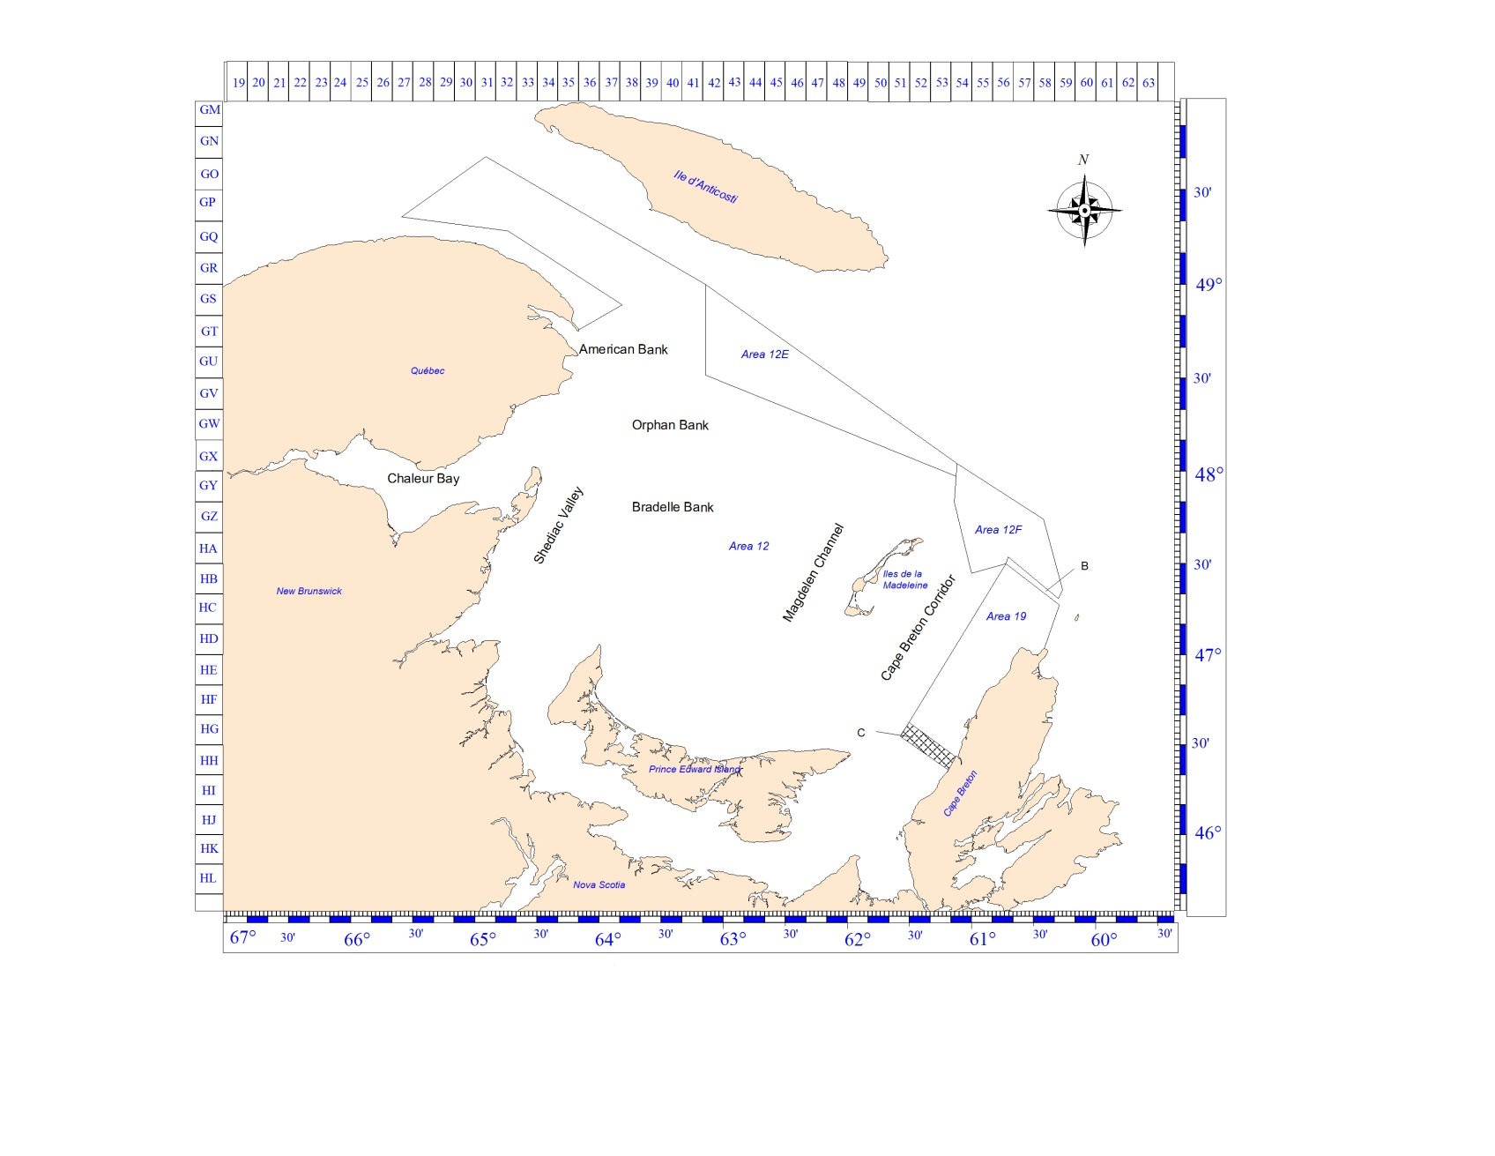*Figure 1. Map of the southern Gulf of St. Lawrence showing snow crab fishery management areas, buffer zones (labels B and C, shaded areas), and commonly used names for fishing grounds.*

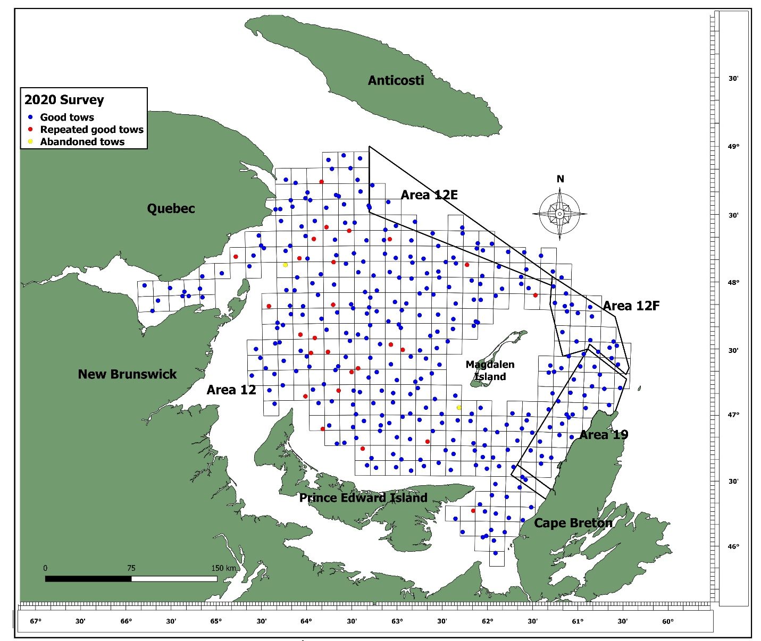

Figure 2. Locations of the 2020 snow crab trawl survey stations. Blue points are successful tows, red points are successful repeat tows, and yellow points are abandoned tows.

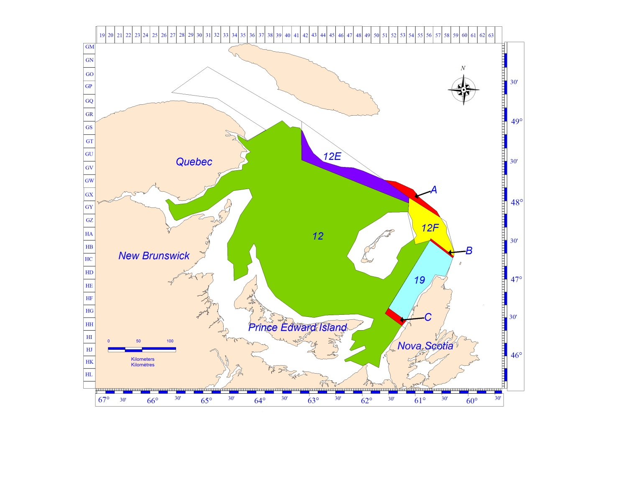

Figure 3. Polygons used for the estimation of commercial biomass for management areas 12, 12E, 12F, and 19 (coloured areas). The unassigned zone north of areas 12E and 12F (label A) and buffer zones (labels B and C) are also shown. The total of the coloured areas corresponds to the sGSL survey area.

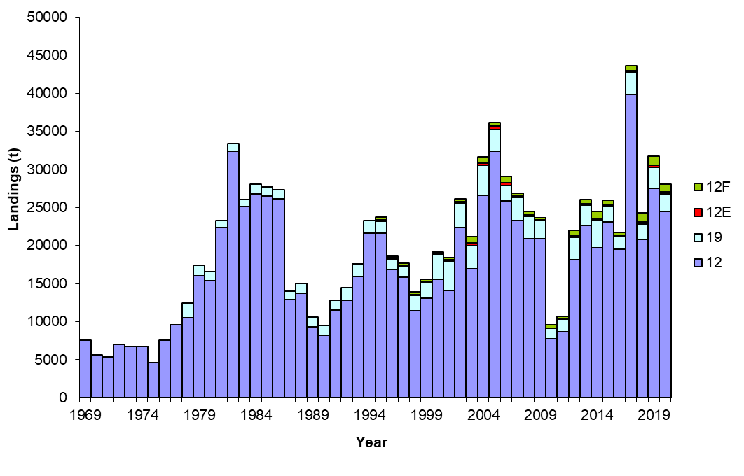

Figure 4. Landings (t) by fishing area and overall in the southern Gulf of Saint Lawrence snow crab fishery, from 1969 to 2020.

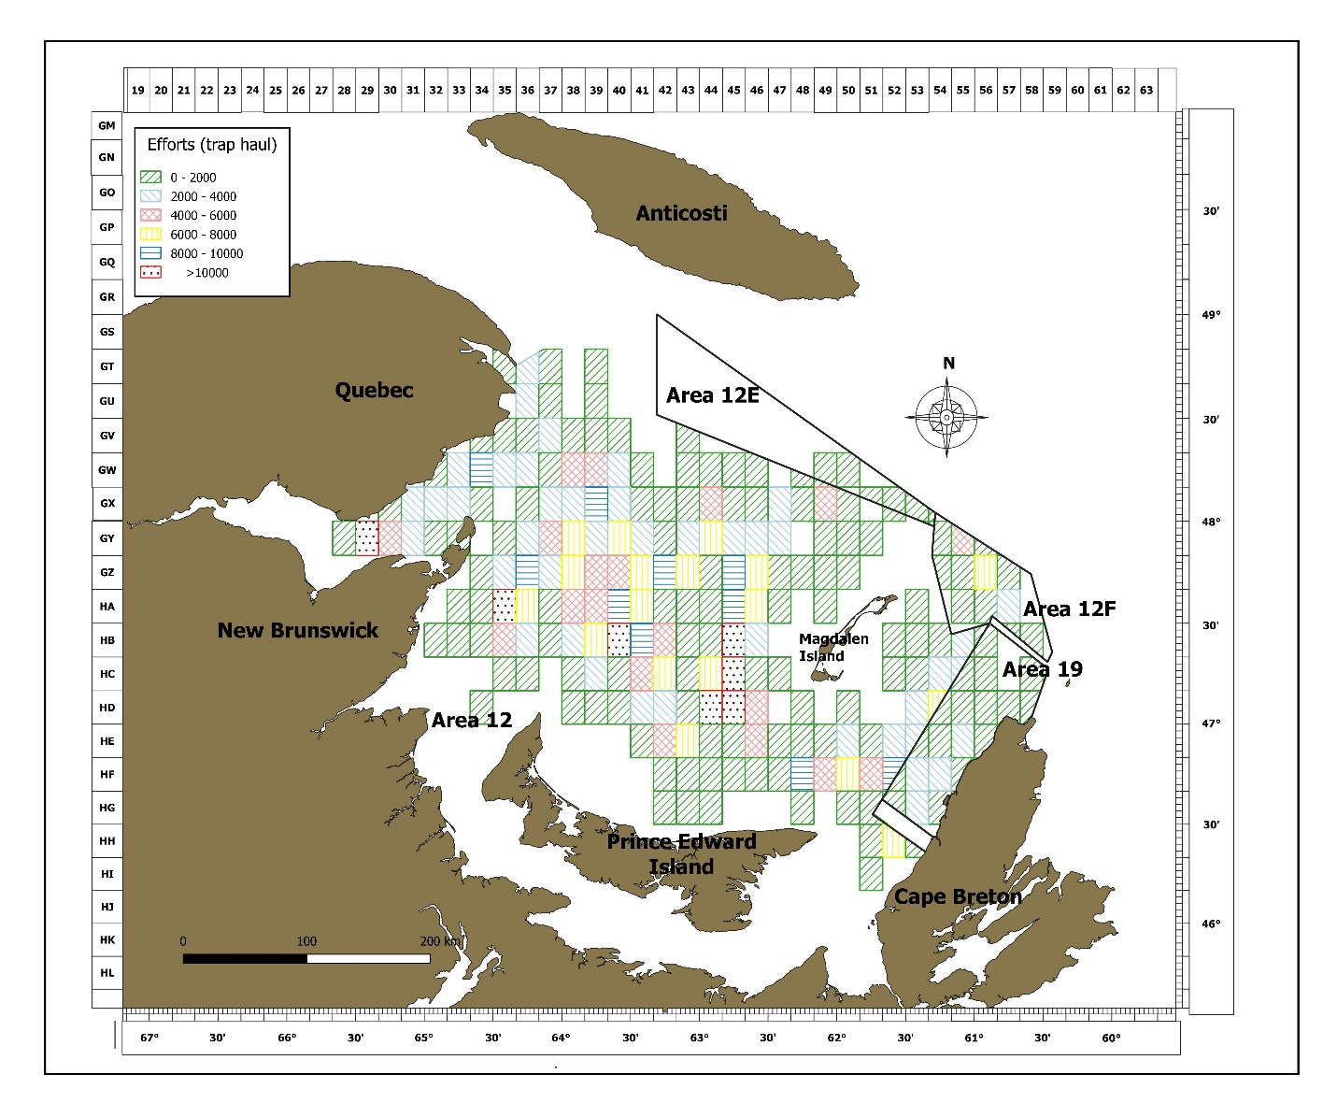

*Figure 5. Geographic distribution of fishing effort (trap hauls) by snow crab fishery management area during the 2020 fishing season.*

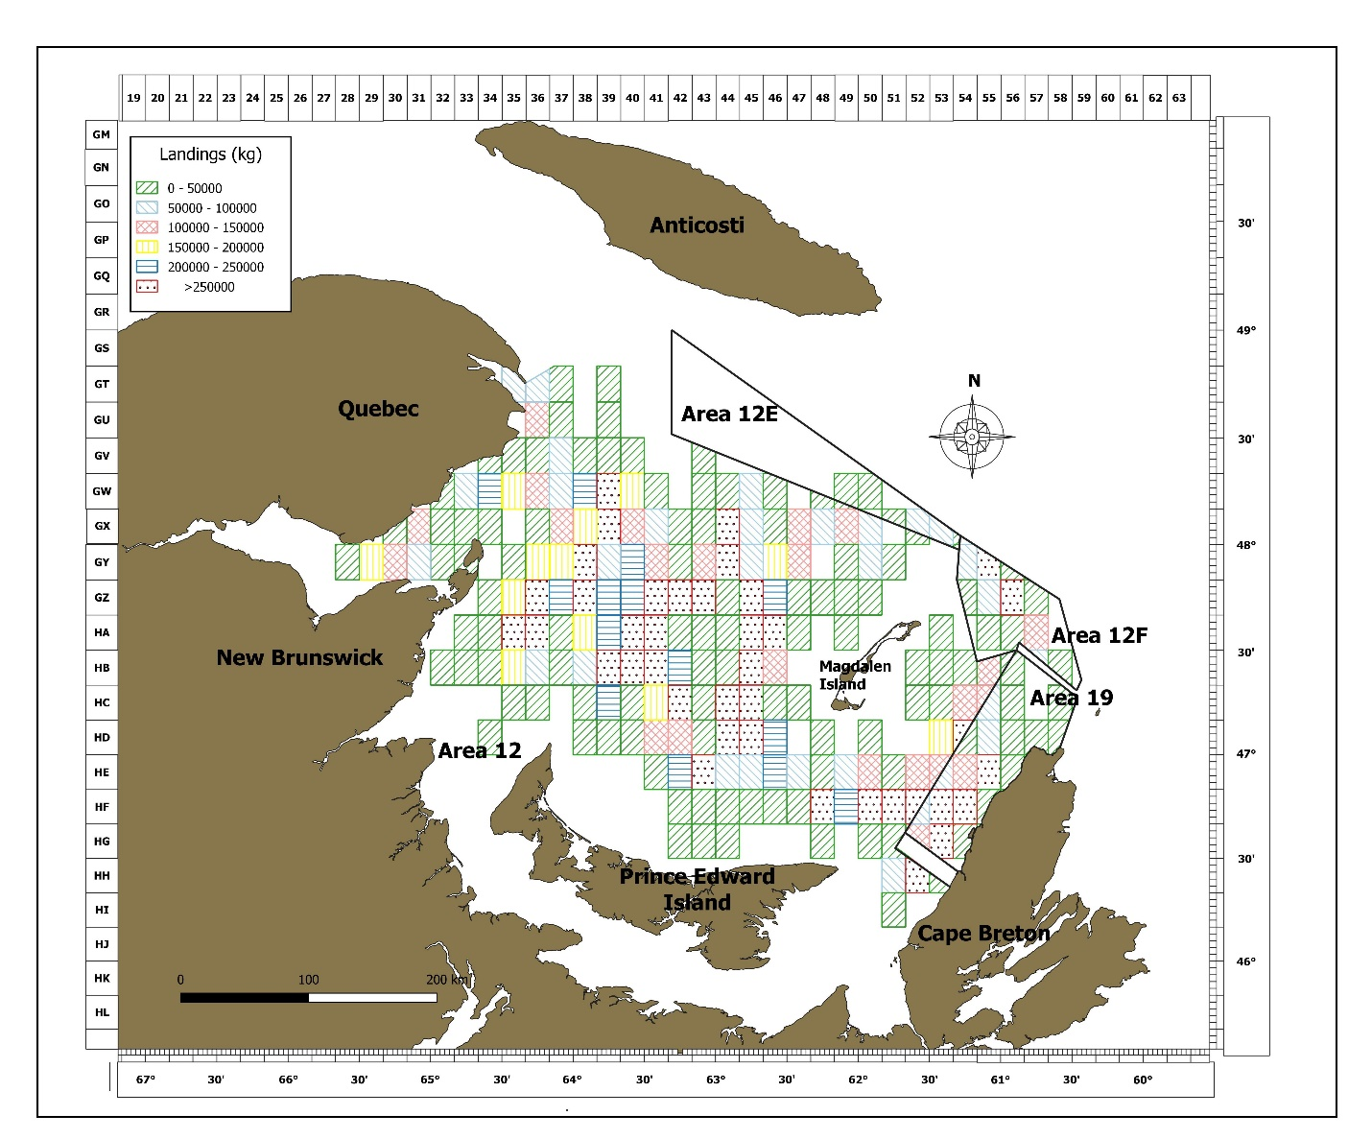

*Figure 6. Geographic distribution of landings (kg) in snow crab fishing management areas during the 2020 fishing season.*

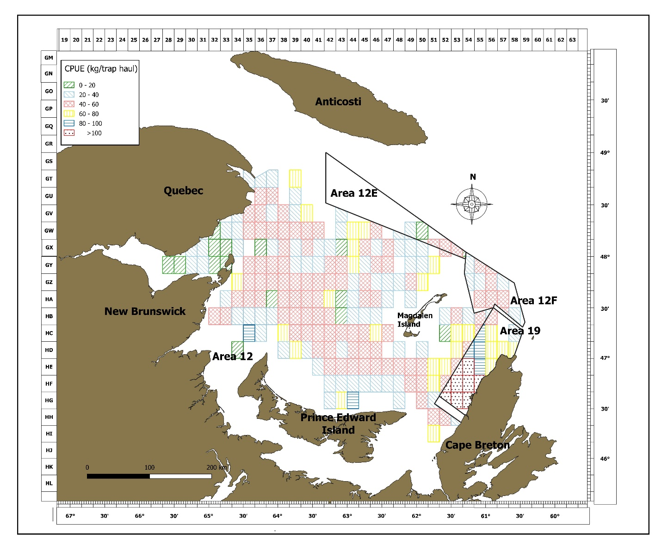

*Figure 7. Geographic distribution of mean catch-per-unit-of-effort (CPUE; kg / th), in the snow crab fishery management areas during the 2020 fishing season.*



Figure 8. Survey vessel tracks during the active (grey lines) and passive trawling phases (red lines). The center point corresponds to the vessel position at the point of trawl touchdown.

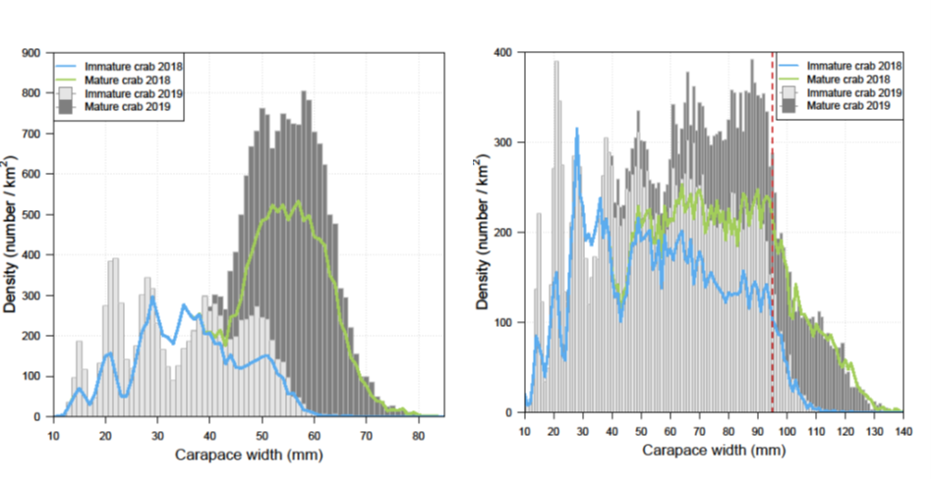

Figure 9. Comparison of the size-frequency distributions from the 2018 and 2019 snow crab surveys for male (left panel) and female (right panel) snow crab. Blue lines indicate 2018 adolescent crab, green lines represent 2018 mature crab, vertical dash red line indicates the 95 mm CW legal size. 2019 adolescent crab are indicated by light grey bars while 2019 mature crab are represented by dark grey bars.

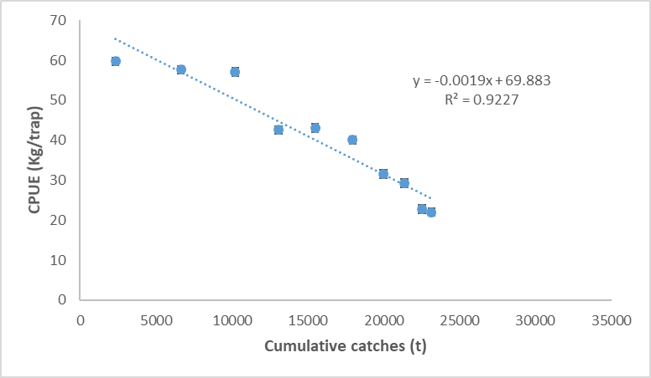

Figure 10. Leslie analysis in the southern Gulf of St. Lawrence snow crab fishery using the 2020 logbook data.



Figure 11. Three-year moving average variogram models for commercial-sized adult male snow crab (Chionoecetes opilio) in the southern Gulf of St. Lawrence, 2013 to 2020. Indicated is the number of observation pairs used per distance lag semi-variance calculation. The red dashed lines indicate the range value on the abscise axis and the nugget and sill values on the y-axis. The green dashed line indicates the variance on the y-axis.

**

Figure 12. Density (kg per km²) contours of commercial-sized (≥ 95 mm of carapace width) adult male snow crab based on sGSL trawl survey, 2010 to 2020.

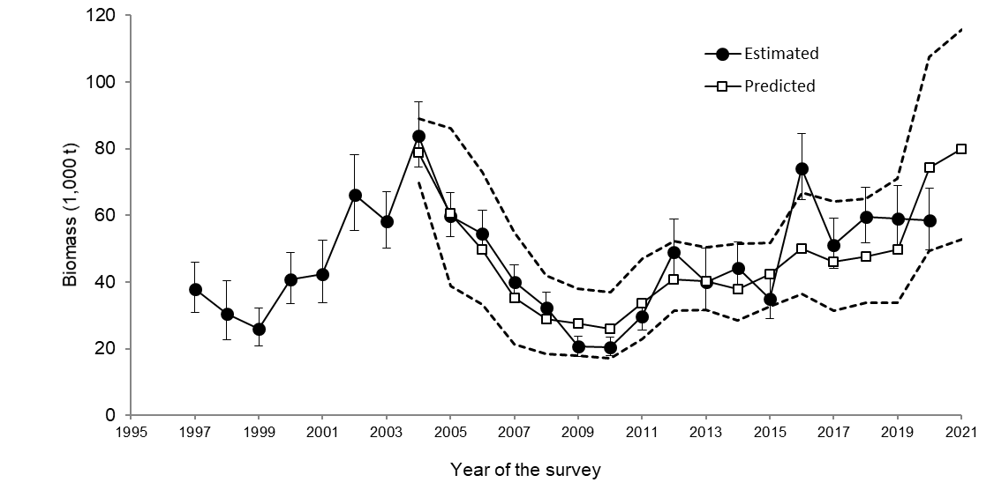

Figure 13. Comparison between the observed (mean with 95% confidence intervals) and forecasted (mean with 95% confidence intervals) recruitment (R-1) of male snow crab based on the Bayesian model on pre-recruits (Surette and Wade 2006; Wade et al. 2014). 2019 and 2020 values are unadjusted for survey catchability bias.

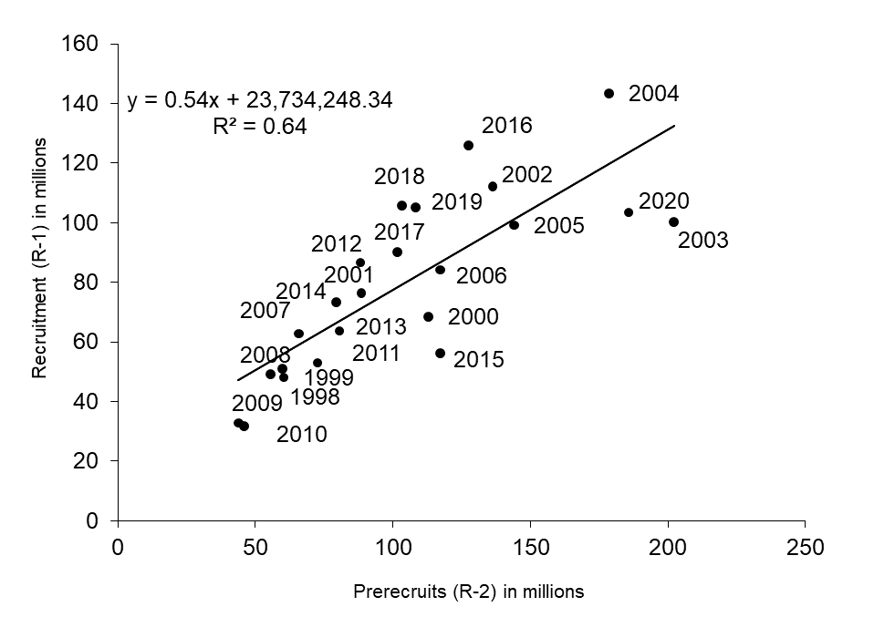

Figure 14. Relationship between the estimated abundance of pre-recruits R-2 in year t -1 and the estimated abundance of the recruitment to the fishery (R-1) in year t from the trawl survey data for the snow crab assessment in the southern Gulf of St. Lawrence.

* Remove equation.

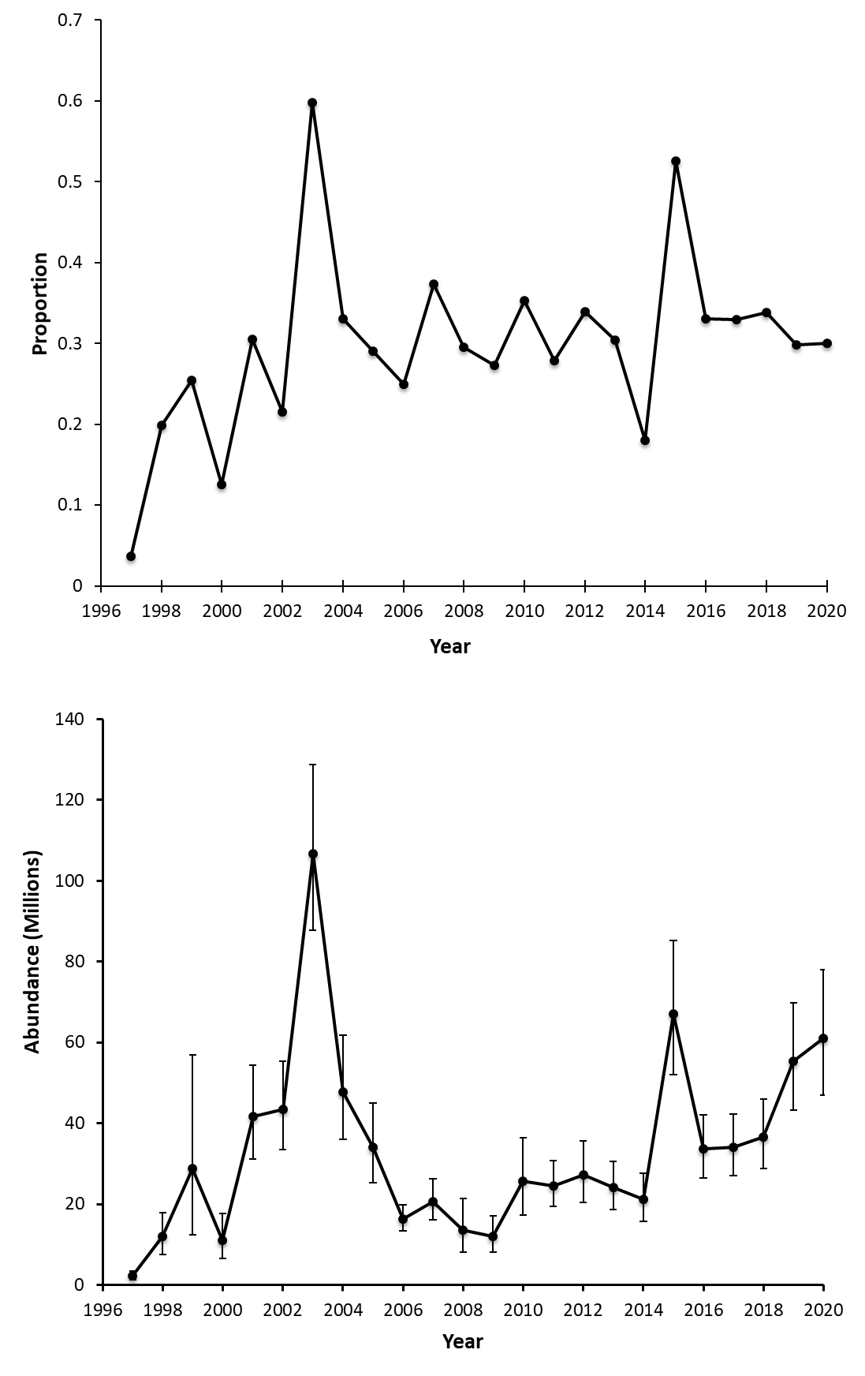

Figure 15. Proportion (top panel) and abundance (bottom panel) and of R-2 adolescent skip-molters in the southern Gulf of St. Lawrence from the sGSL trawl survey.

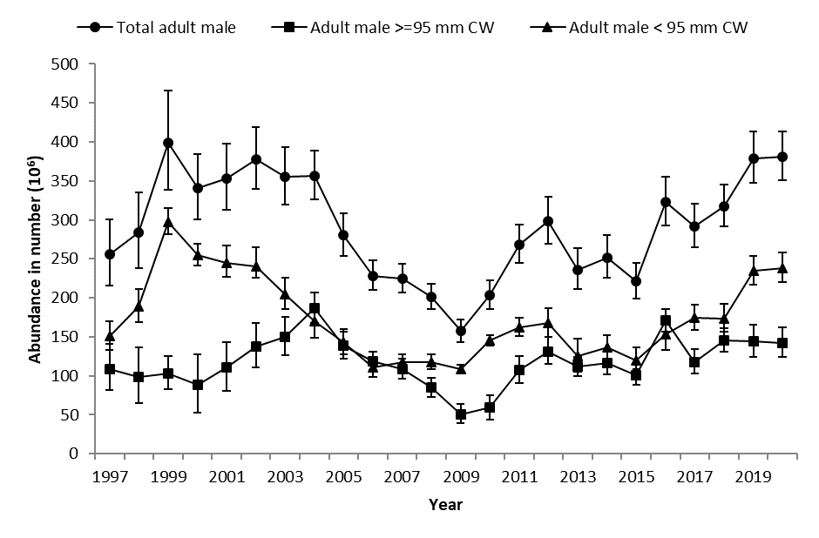

Figure 16. Survey abundance (in millions) of snow crab adult males in the southern Gulf of St. Lawrence, 1997 to 2020.

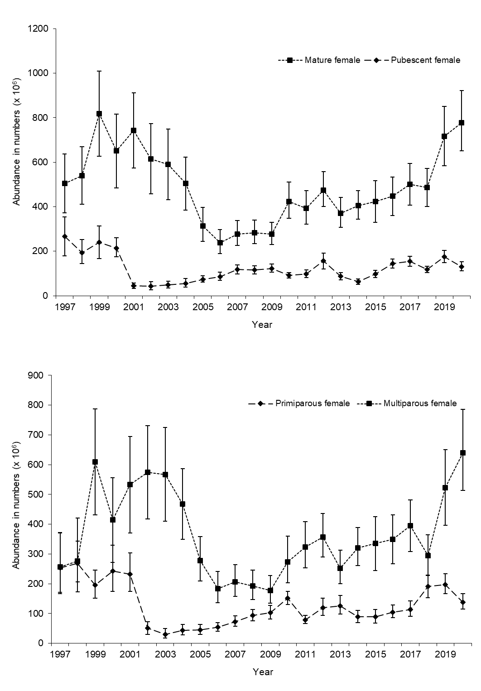

Figure 17. Abundance (in millions) of mature and pubescent (above), and primiparous, and multiparous (i.e. mature; below) snow crab females in the southern Gulf of St. Lawrence, 1997 to 2020.

**

Figure 18.Size-frequency distributions of immature and pubescent (black bars) and mature female (white bars) snow crab from the sGSL survey, from 2005 to 2020.

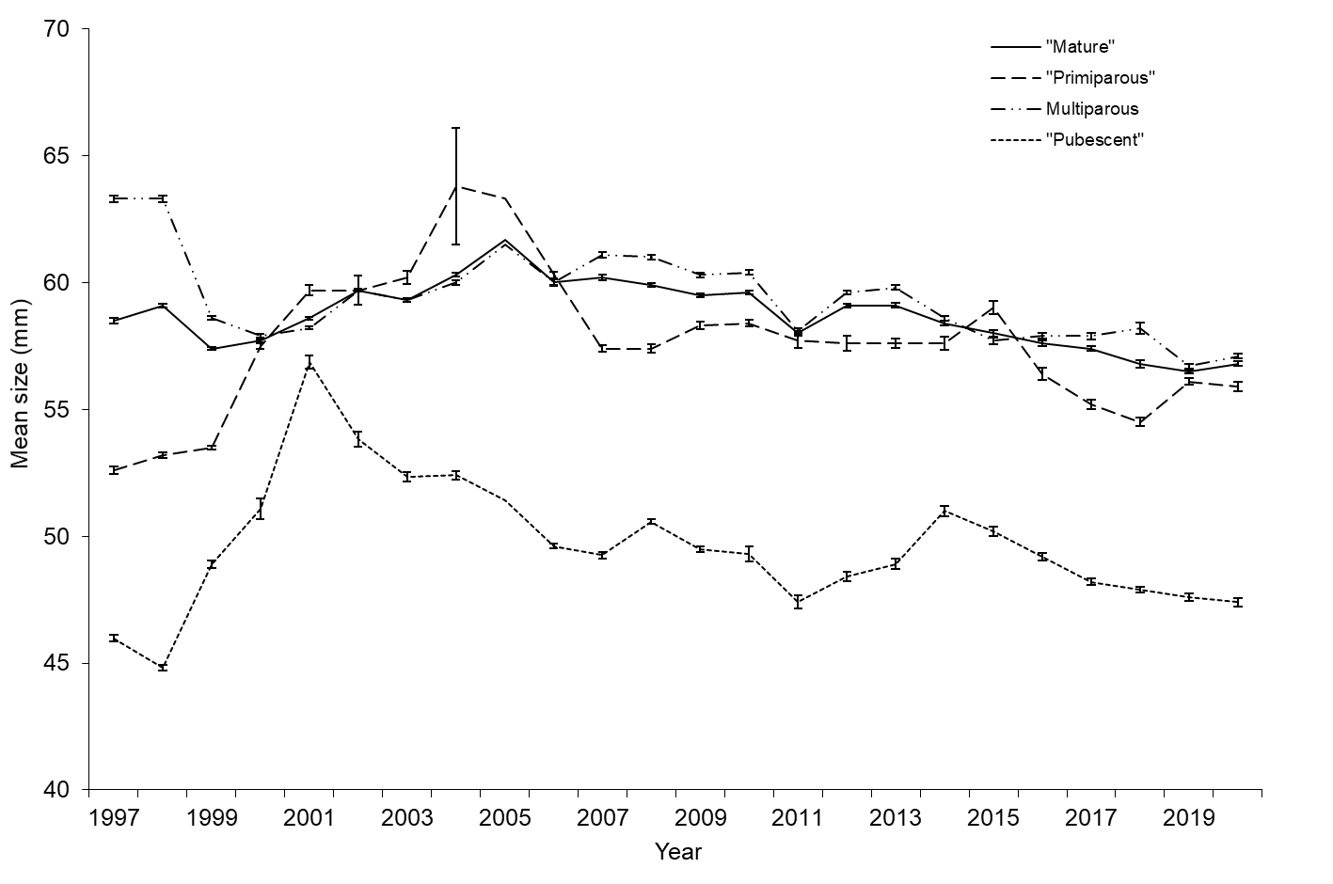

Figure 19. Mean sizes of female snow crab by maturity stage through time, based on sGSL trawl survey data. Error bars show 95% confidence intervals.

* Redo this figure to be clearer, with colours.
* Y-axis “Carapace width (mm)”
* Error bars should be standard errors.

**

Figure 20. Size-frequency distributions of immature and pubescent (black bars) and mature female (white bars) snow crab from the sGSL survey, from 2005 to 2020. The red dotted line shows the minimum legal size of 95 mm CW.

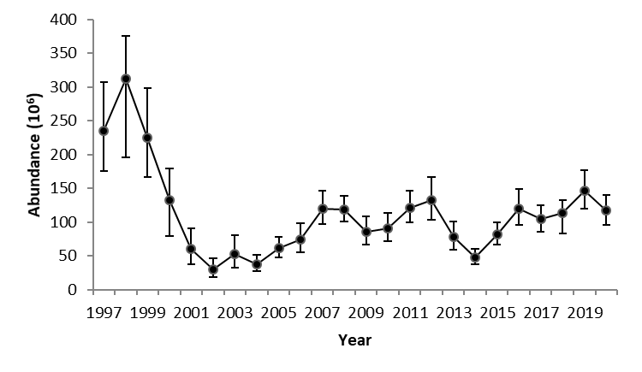

Figure 21. Abundance indices of adolescent male snow crab sizes 34-44 mm CW (instar VIII) from the sGSL trawl survey. These crab reach legal size in approximately 6 years.



Figure 22. Snow crab (Chionoecetes opilio) recruitment (R) abundance (mean with 95% confidence intervals) by pre-recruit stages (Rj), where j =1,…,4 years until recruitment to the fishery based on the survey data estimates. Shaded areas are forecasted abundance from the Bayesian model (Wade et al. 2014). Uncorrected



Figure 23. Density (number per km²) contours of adolescent male (R-4, R-3 and R-2) snow crab, ≥ 56 mm CW, based on trawl survey data from 2010 to 2020.

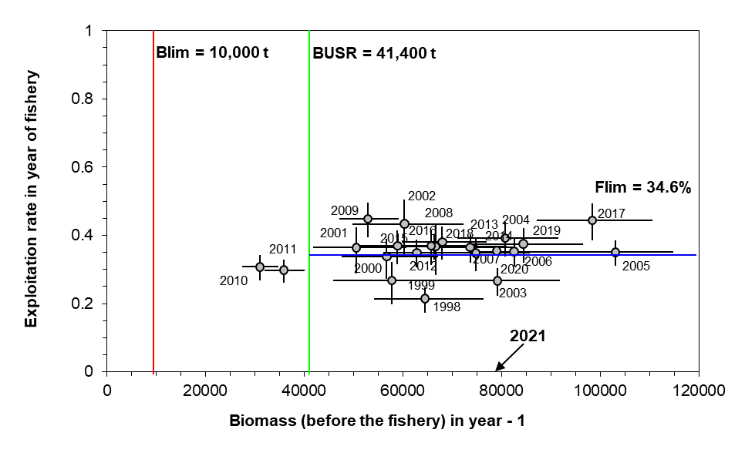Figure 24. Exploitation rate versus the commercial biomass from the previous year. Year labels represent the year of the fishery. Colored lines represent reference points: Blim is the limit reference point for residual biomass, Flim is the limit reference point for fishing removal rate, and Busr is the upper stock reference point for commercial biomass.

* *Colored lines should be thicker.*
* *X-axis should be labelled as commercial biomass*

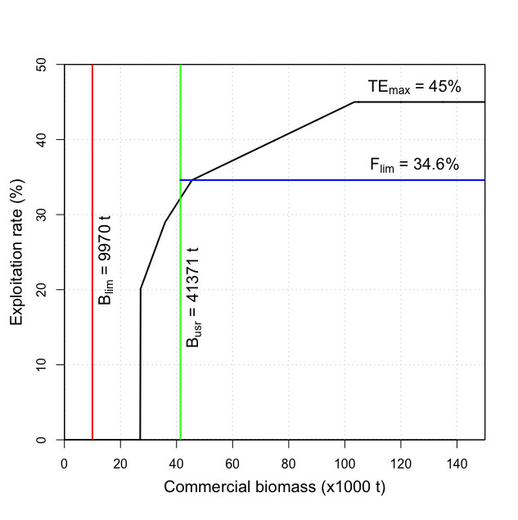

Figure 25. Harvest control rule used for the southern Gulf of St. Lawrence snow crab fishery (DFO 2014a), expressed as exploitation rate versus commercial biomass (black line). Coloured lines represent reference points: Blim is the limit reference point for residual biomass, Flim is the limit reference point for fishing removal rate, and Busr is the upper stock reference point for commercial biomass. TEmax represents the maximum exploitation rate harvest control rule.

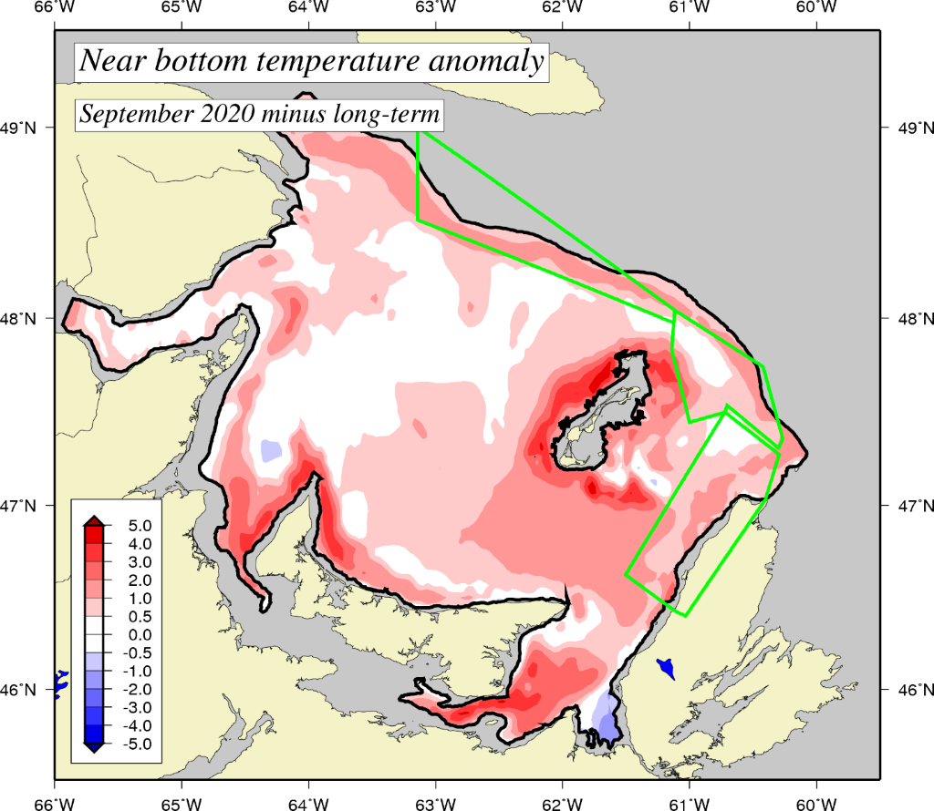

*Figure 26*. *Near-bottom temperature departure (°C) from the long-term (1991-2020) mean in the southern Gulf of St. Lawrence during September 2020. Blue areas represent colder-than-normal temperatures while red regions represent warmer-than-normal conditions.*

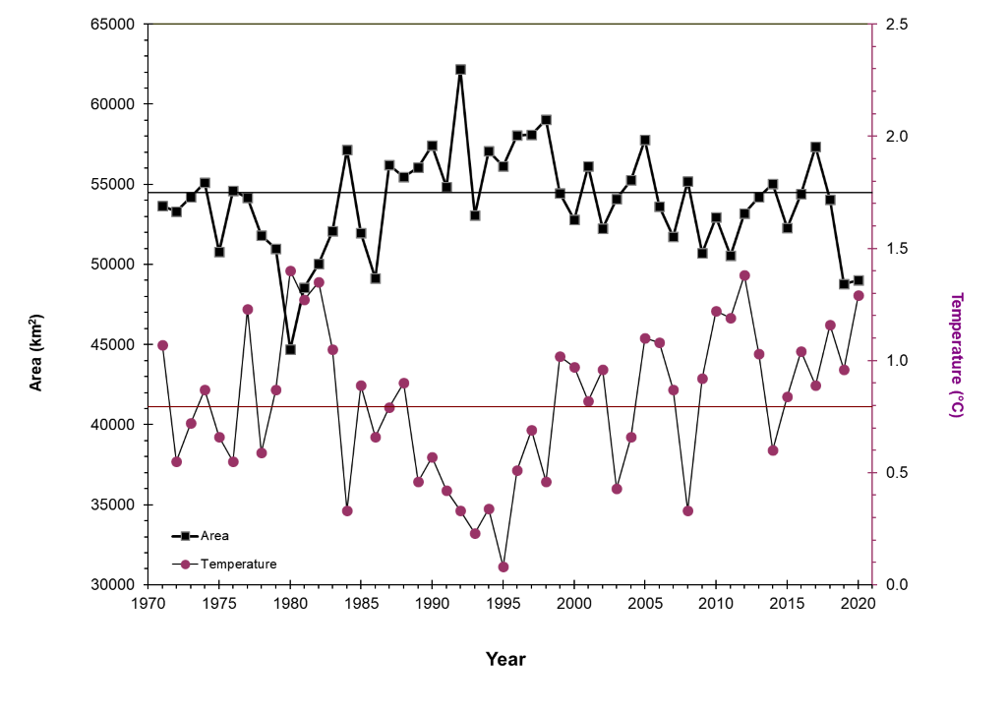

Figure 27. Snow crab temperature habitat area index (km2) that encompasses water temperatures of -1 to 3°C (upper panel) and the mean temperature (°C)) within the temperature area index (lower panel) in the southern Gulf of St. Lawrence, 1971 to 2020.